
L. J. Institute of Computer Application
L. J. University

Master of Computer Application

3rd Semester

Project Name :-
CarZen: Car Selling, Buying, Service System

Submitted To:
Mrs. Dharmi Doshi

Submitted By:
Boghara Aayush M Roll No: E01 25004401110004
Chudasama Vishal B Roll No: E02 25004401110069
Sakariya Pinak B Roll No: E06 25004401110067

Introduction

1.1 Problem Definition
The existing process of buying, selling, and servicing cars is often dependent on manual searches, individual dealers, classified advertisements, and personal estimation of vehicle prices. Buyers may find it difficult to determine whether a car is fairly priced, while sellers may not know the appropriate resal value of their vehicle.
There is also a lack of an integrated platform that combines car buying, car selling, vehicle service information, and price prediction in a single system.
The proposed CarZen system aims to develop an integrated vehicle marketplace and management platform that allows users to list cars for sale, search and compare available cars, manage information, access service-related information, and estimate the expected price of a vehicle using a machine-learning-based prediction system.
The frontend will be developed using Flutter. The backend will be developed using Python and FastAPI, while MySQL will store user, vehicle, selling, reselling, service, and prediction-related information.

1.2 Objective of the New System
The main objective is to develop an integrated platform for car buying, selling, reselling, servicing, and -price prediction.
- Provide a platform for users to buy and sell new or used cars.
- Allow sellers to create and manage car listings.
- Allow buyers to search and filter cars according to their requirements.
- Provide detailed information about available vehicles.
- Support reselling by maintaining vehicle and ownership information.
- Provide information related to vehicle servicing and maintenance.
- Predict the estimated price of a car using machine learning.
- Store system data securely and consistently using MySQL.
- Provide REST APIs using FastAPI for communication with the Flutter frontend.
- Provide an admin module for managing users, cars, services, listings and system data.
- Reduce the difficulty of estimating the market value of used cars.
- Improve transparency between buyers and sellers.

1.3 Core Components
Component | Description
User Management | Registration, login, authentication, profile management and role-based access.
Car Management | Vehicle attributes, listings, search and filtering.
Car Selling Module | Create, update, delete and manage vehicle listings and selling status.
Car Buying/Search Module | Search, filter, compare and view available vehicles.
Reselling Module | Ownership chain, purchase information, listing and history.
Car Service Module | Service type, date, cost, center, maintenance details and service history.
Price Prediction Module | Estimate expected value from relevant vehicle characteristics and historical data.
Admin Module | Manage users, cars, listings, service information, prediction records and system data.
FastAPI Backend | RESTful APIs connecting Flutter, business logic, database and prediction services.
MySQL Database | Primary relational database for structured application data.

1.4 Project Profile
Attribute | Specification
Project Name | CarZen — Car Selling, Reselling, Service and Price Prediction System
Project Type | Cross-platform application / marketplace platform
Domain | Automobile / E-Commerce / Machine Learning
Frontend | Flutter
Backend Language | Python
Backend Framework | FastAPI
Database | MySQL
API Architecture | REST API
Prediction | Machine Learning
Main Users | Buyers, Sellers, Car Owners, Service Providers and Administrator
Main Purpose | Car buying, selling, reselling, service management and -price prediction

1.5 Need of the New System
- Difficulty in determining the correct car price: users may not know the market value of a used vehicle.
- Lack of centralized information: car information, selling information and service records may be distributed across different sources.
- Manual price estimation: prices are often estimated from personal experience rather than a consistent data-driven method.
- Difficulty in finding suitable cars: buyers need efficient search and filtering.
- Limited vehicle history information: previous ownership and service information may not be easily available.
- Lack of integrated service management: service information is often maintained separately.
- Need for an organized used-car workflow: buying and reselling activities benefit from a centralized platform.
- Need for data-driven prediction: machine learning can estimate price from historical and current vehicle attributes.

1.6 Scope of the New System
Scope Area | Included Functions
Buyer Scope | Registration/login; search; filtering; comparison; vehicle details; expected price; seller information; service information.
Seller Scope | Seller registration; car listing; vehicle information/images; asking price; update/remove listing; selling status.
Reselling Scope | Add vehicle; ownership information; previous purchase details; -price estimate; listing; history.
Service Scope | Add service records; view service history; service dates; service costs; maintenance information.
Prediction Scope | Use historical/current vehicle attributes to estimate expected price.
Admin Scope | Manage users, vehicles, listings, service records, prediction data, reported content and system activity.

Advantages and Limitations of the Proposed System

Advantages
- Provides a single platform for car buying, selling and reselling.
- Makes it easier to search and filter vehicles.
- Helps users estimate the value of a car.
- Maintains vehicle, ownership and service information.
- Provides secure and structured data management using MySQL.
- Helps buyers and sellers make better pricing and purchasing decisions.

Limitations
- Prediction accuracy depends on the quality of available data.
- Predicted price may differ from the actual market price.
- Incorrect vehicle information can affect the prediction result.
- The system requires a reliable internet connection.
- Service and prediction features may have limited coverage during the initial implementation.

1.8 Proposed Time Line Chart
Phase | Activities | Duration | Progress
Phase 1 | Requirement Analysis | Week 1 | ✓
Phase 2 | System Analysis and Planning | Week 2 | ✓
Phase 3 | Database Design using MySQL | Week 3 | ✓
Phase 4 | System and API Design | Week 4 | ✓
Phase 5 | User and Authentication Module | Week 5 | ✓
Phase 6 | Car Buying Module | Week 6 | ✓
Phase 7 | Car Selling Module | Week 7
Phase 8 | Car Service Module | Week 8
Phase 9 | Dataset Preparation and ML Model | Week 9
Phase 10 | Price Prediction Integration | Week 10
Phase 11 | Testing and Bug Fixing | Week 11
Phase 12 | Final Documentation and Deployment | Week 12

1.9 Targeted Users
User Type | Main Purpose / Responsibilities
Buyers | Search for and purchase new or used cars; view details, service information and predicted value.
Sellers | List vehicles, set prices, update listings and manage selling status.
Car Owners | Maintain vehicle/service information and determine expected value.
Service Providers | Add and update vehicle maintenance records and service history.
Administrator | Manage users, vehicles, listings, services, prediction records and overall system operations.

2. Requirement Determination and Analysis

2.1 Requirement Determination
Requirement determination identifies the main requirements needed to develop and operate the Caren – Car Selling, Buying, Service & Price Prediction System.
The major requirements are:
Functional Requirements
- User registration and login.
- User profile management and authentication.
- Add, update and delete car information.
- Create and manage car listings.
- Search and filter available cars.
- View detailed vehicle information.
- Manage favourites and inquiries.
- Maintain ownership and information.
- Maintain vehicle service records.
- Predict estimated price using Machine Learning.
- Admin management of users, cars and listings.
Non-Functional Requirements
- Security: Secure authentication and authorization.
- Performance: Fast response to user requests.
- Reliability: Maintain consistent and accurate data.
- Scalability: Support increasing users and vehicle records.
- Usability: Simple and user-friendly interface.
- Maintainability: Modular and easily maintainable backend.
Technical Requirements
- Frontend: Flutter
- Backend: Python + Fast API
- Database: MySQL
- API: REST API
- Machine Learning: Python ML libraries
- Testing: Postman
- Version Control: Git/GitHub

2.2 Requirement Specification
The following specifications define what the Caren system should provide.
Module | Requirement
User Management | Register, login and manage user profile.
Car Management | Add, update, delete and view vehicle information.
Listing Management | Create, update and manage car sale/ listings.
Search | Search and filter cars according to requirements.
Ownership | Maintain vehicle ownership and transaction history.
Service | Store and view vehicle service and maintenance records.
Price Prediction | Accept vehicle details and provide estimated price.
Favorites | Allow users to save preferred vehicles.
Inquiry | Maintain buyer-seller communication/inquiry information.
Admin | Manage users, cars, listings and system data.

Database Requirements
The system requires a relational MySQL database to store:
Users, Addresses, Cars, Car Brands, Car Models, Car Variants, Listings, Ownership History, Service Records, Favourites, Inquiries, Transactions and Price Predictions.

Machine Learning Requirements
The prediction module will use vehicle information such as brand, model, manufacturing year, mileage, fuel type, transmission, engine capacity, number of owners, condition and location to estimate the price.

3. System Design

3.1 Use Case Diagram
The Use Case Diagram represents the interaction between users and the Car Service & Used Car Web Paortal. It shows the major functions available to different types of users. The Customer can register, log in, manage their profile, book car services, view booking status, and cancel bookings. The Seller can register, manage their profile, list used cars, manage listings, and remove listings. The diagrams also show the activities required for service booking and used-car listing.
Admin Diagram
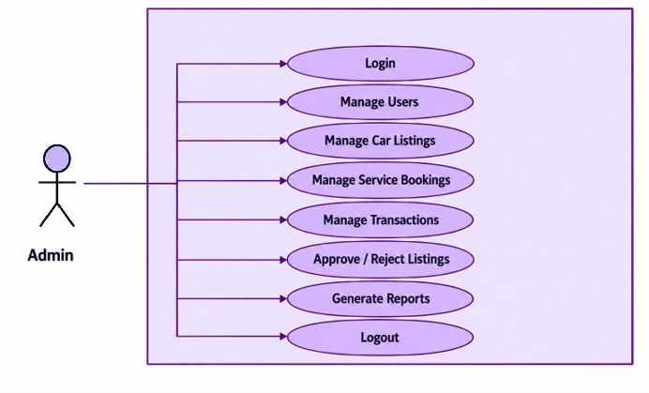

Seller Diagram
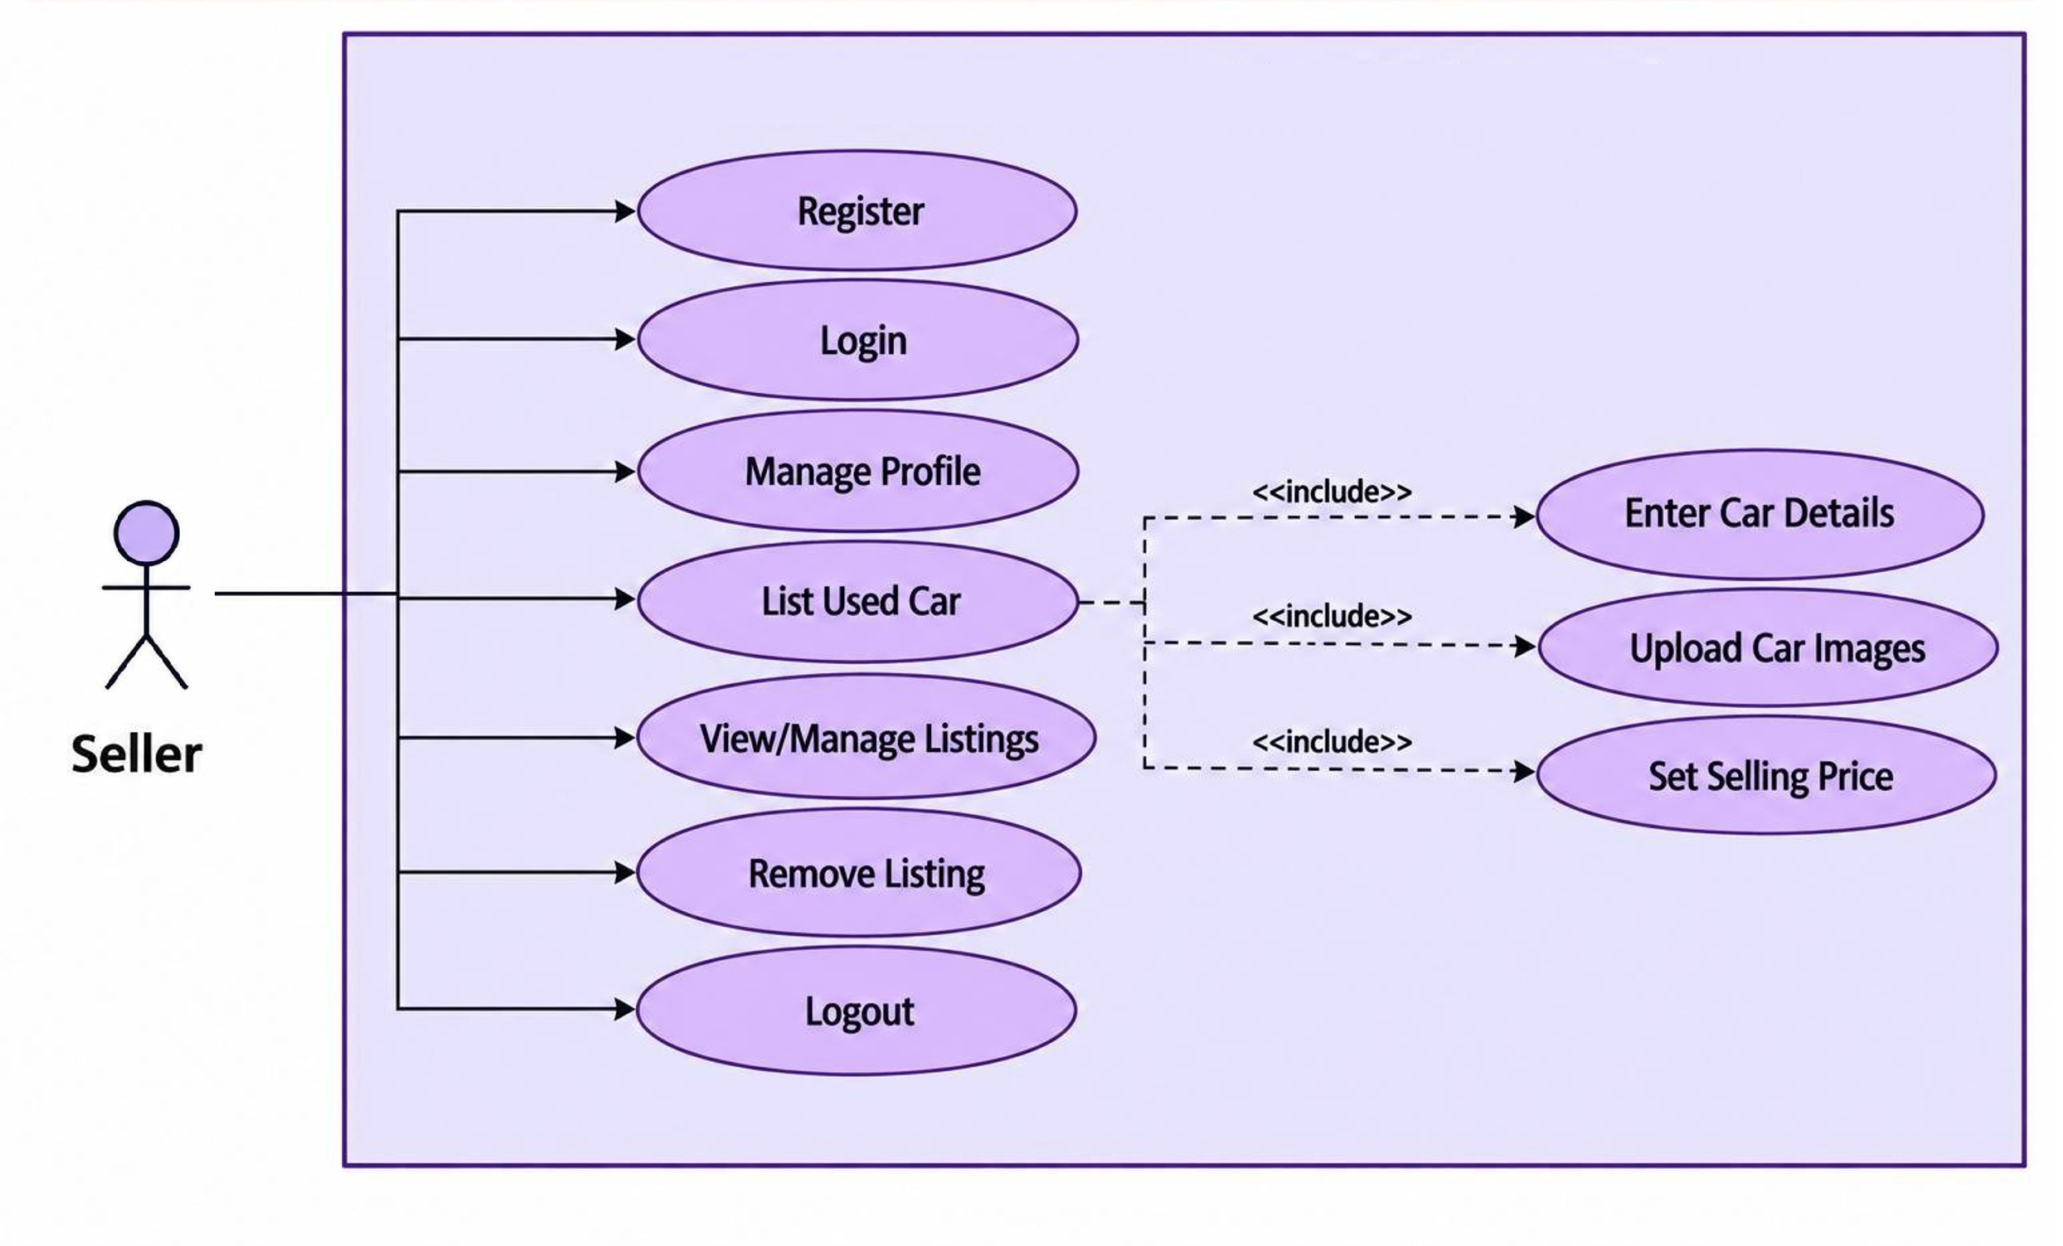
Customer (User) Diagram
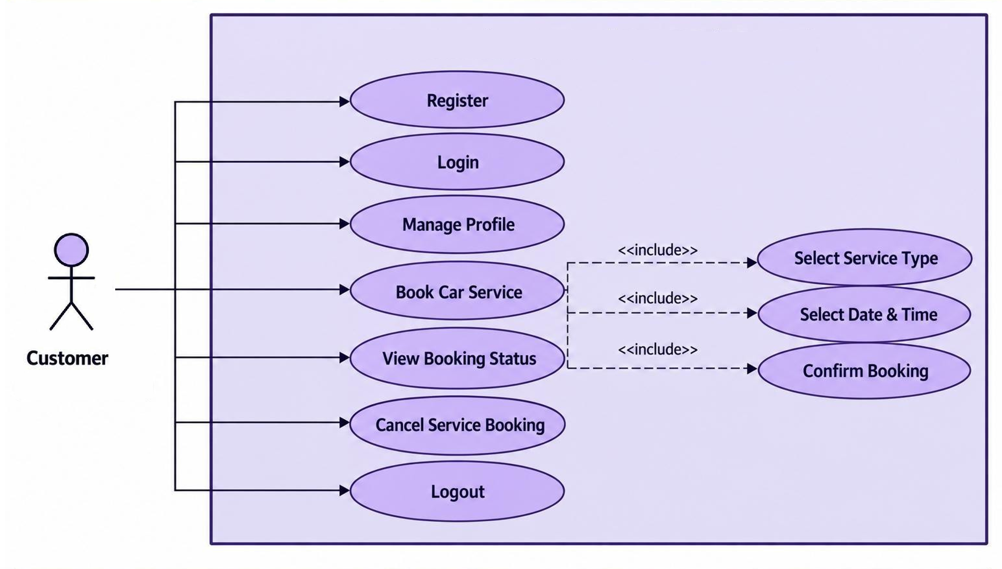

3.2 Data Dictionary
The Data Dictionary describes the database structure of the Car Service & Used Car Web Portal. It lists each database table, its fields, data types, key information, nullability, default values, and the purpose of each field. The dictionary is prepared directly from the provided SQL database schema

users
Field Name | Data Type | Nullable | Default | Key | Description
id | bigint | No | — | Primary Key | Unique identifier.
first_name | varchar(100) | No | — | — | First name of the user.
last_name | varchar(100) | Yes | — | — | Last name of the user.
username | varchar(100) | No | — | — | Unique username of the user.
email | varchar(150) | No | — | — | Unique email address.
password_hash | varchar(255) | No | — | — | Hashed password value.
phone_number | varchar(20) | Yes | — | — | User or service-center contact number.
role | ENUM | No | — | — | Role assigned to the user or administrator.
status | ENUM | Yes | — | — | Current status of the record.
profile_image_url | varchar(500) | Yes | — | — | URL of the profile image.
created_at | timestamp | Yes | — | — | Date and time when the record was created.
updated_at | timestamp | Yes | — | — | Date and time when the record was last updated.
deleted_at | timestamp | Yes | — | — | Date and time associated with deletion.

car_brands
Field Name | Data Type | Nullable | Default | Key | Description
id | bigint | No | — | Primary Key | Unique identifier.
name | varchar(100) | No | — | — | Name of the brand, model, or service center.
slug | varchar(120) | No | — | — | Unique URL-friendly identifier.
country | varchar(100) | Yes | — | — | Country.
logo_url | varchar(500) | Yes | — | — | URL of the brand logo.
description | text | Yes | — | — | Description or additional details.
is_active | boolean | Yes | — | — | Indicates whether the administrator account is active.
created_at | timestamp | Yes | — | — | Date and time when the record was created.
updated_at | timestamp | Yes | — | — | Date and time when the record was last updated.
deleted_at | timestamp | Yes | — | — | Date and time associated with deletion.

car_models
Field Name | Data Type | Nullable | Default | Key | Description
id | bigint | No | — | Primary Key | Unique identifier.
brand_id | bigint | No | — | Foreign Key | Identifier of the related car brand.
name | varchar(100) | No | — | — | Name of the brand, model, or service center.
slug | varchar(120) | No | — | — | Unique URL-friendly identifier.
body_type | ENUM | Yes | — | — | Body type of the car model.
seating_capacity | integer | Yes | — | — | Number of seats.
description | text | Yes | — | — | Description or additional details.
is_active | boolean | Yes | — | — | Indicates whether the administrator account is active.
created_at | timestamp | Yes | — | — | Date and time when the record was created.
updated_at | timestamp | Yes | — | — | Date and time when the record was last updated.
deleted_at | timestamp | Yes | — | — | Date and time associated with deletion.

car_variants
Field Name | Data Type | Nullable | Default | Key | Description
id | bigint | No | — | Primary Key | Unique identifier.
model_id | bigint | No | — | Foreign Key | Identifier of the related car model.
variant_name | varchar(150) | No | — | — | Name of the car variant.
fuel_type | ENUM | No | — | — | Fuel type of the vehicle.
transmission | ENUM | No | — | — | Transmission type of the vehicle.
engine_cc | decimal(8,2) | Yes | — | — | Engine capacity in cubic centimetres.
horsepower | decimal(8,2) | Yes | — | — | Engine power in horsepower.
seating_capacity | integer | Yes | — | — | Number of seats.
ex_showroom_price | decimal(15,2) | Yes | — | — | Ex-showroom price of the variant.
created_at | timestamp | Yes | — | — | Date and time when the record was created.
updated_at | timestamp | Yes | — | — | Date and time when the record was last updated.
deleted_at | timestamp | Yes | — | — | Date and time associated with deletion.

cars
Field Name | Data Type | Nullable | Default | Key | Description
id | bigint | No | — | Primary Key | Unique identifier.
variant_id | bigint | No | — | Foreign Key | Identifier of the related car variant.
owner_id | bigint | No | — | Foreign Key | Identifier of the vehicle owner.
registration_number | varchar(30) | Yes | — | — | Vehicle registration number.
vin_number | varchar(100) | Yes | — | — | Vehicle identification number (VIN).
manufacturing_year | integer | No | — | — | Year in which the vehicle was manufactured.
registration_year | integer | Yes | — | — | Year in which the vehicle was registered.
fuel_type | ENUM | No | — | — | Fuel type of the vehicle.
transmission | ENUM | No | — | — | Transmission type of the vehicle.
engine_cc | decimal(8,2) | Yes | — | — | Engine capacity in cubic centimetres.
horsepower | decimal(8,2) | Yes | — | — | Engine power in horsepower.
mileage_km | decimal(12,2) | No | — | — | Vehicle mileage in kilometres.
color | varchar(50) | Yes | — | — | Vehicle colour.
seating_capacity | integer | Yes | — | — | Number of seats.
owner_count | integer | Yes | — | — | Number of owners.
ownership_type | ENUM | Yes | — | — | Ownership sequence/type.
condition | ENUM | No | — | — | Current condition of the vehicle.
insurance_company | varchar(150) | Yes | — | — | Name of the insurance company.
insurance_type | varchar(100) | Yes | — | — | Type of insurance.
insurance_expiry | date | Yes | — | — | Insurance expiry date.
rc_status | varchar(50) | Yes | — | — | Registration Certificate status.
city | varchar(100) | No | — | — | City.
state | varchar(100) | No | — | — | State or region.
country | varchar(100) | Yes | — | — | Country.
postal_code | varchar(10) | Yes | — | — | Postal/PIN code.
description | text | Yes | — | — | Description or additional details.
expected_market_price | decimal(15,2) | Yes | — | — | Data field used by the system.
is_verified | boolean | Yes | — | — | Indicates whether the record is verified.
created_at | timestamp | Yes | — | — | Date and time when the record was created.
updated_at | timestamp | Yes | — | — | Date and time when the record was last updated.
deleted_at | timestamp | Yes | — | — | Date and time associated with deletion.

car_media
Field Name | Data Type | Nullable | Default | Key | Description
id | bigint | No | — | Primary Key | Unique identifier.
car_id | bigint | No | — | Foreign Key | Identifier of the related car.
media_type | ENUM | No | — | — | Type of media associated with the car.
media_url | varchar(500) | No | — | — | URL of the media file.
thumbnail_url | varchar(500) | Yes | — | — | URL of the media thumbnail.
file_name | varchar(255) | Yes | — | — | Name of the uploaded file.
file_size | bigint | Yes | — | — | Size of the uploaded file.
sort_order | integer | Yes | — | — | Display order of the media item.
is_primary | boolean | Yes | — | — | Indicates whether the media item is primary.
created_at | timestamp | Yes | — | — | Date and time when the record was created.
deleted_at | timestamp | Yes | — | — | Date and time associated with deletion.

listings
Field Name | Data Type | Nullable | Default | Key | Description
id | bigint | No | — | Primary Key | Unique identifier.
car_id | bigint | No | — | Foreign Key | Identifier of the related car.
seller_id | bigint | No | — | Foreign Key | Identifier of the seller.
listing_type | ENUM | No | — | — | Type of listing.
title | varchar(255) | No | — | — | Title of the listing.
description | text | Yes | — | — | Description or additional details.
asking_price | decimal(15,2) | No | — | — | Price requested for the listing.
negotiable | boolean | Yes | — | — | Indicates whether the asking price is negotiable.
listing_status | ENUM | Yes | — | — | Current status of the listing.
listed_at | timestamp | Yes | — | — | Date and time when the listing was listed.
expiry_date | timestamp | Yes | — | — | Date and time when the listing expires.
views_count | integer | Yes | — | — | Number of listing views.
created_at | timestamp | Yes | — | — | Date and time when the record was created.
updated_at | timestamp | Yes | — | — | Date and time when the record was last updated.
deleted_at | timestamp | Yes | — | — | Date and time associated with deletion.

ownership_history
Field Name | Data Type | Nullable | Default | Key | Description
id | bigint | No | — | Primary Key | Unique identifier.
car_id | bigint | No | — | Foreign Key | Identifier of the related car.
owner_id | bigint | No | — | Foreign Key | Identifier of the vehicle owner.
ownership_number | integer | No | — | — | Sequential ownership number.
ownership_type | ENUM | Yes | — | — | Ownership sequence/type.
purchase_date | date | Yes | — | — | Date of purchase.
sale_date | date | Yes | — | — | Date of sale.
purchase_price | decimal(15,2) | Yes | — | — | Purchase price.
sale_price | decimal(15,2) | Yes | — | — | Sale price.
purchase_location | varchar(150) | Yes | — | — | Location of purchase.
sale_location | varchar(150) | Yes | — | — | Location of sale.
created_at | timestamp | Yes | — | — | Date and time when the record was created.

service_centers
Field Name | Data Type | Nullable | Default | Key | Description
id | bigint | No | — | Primary Key | Unique identifier.
owner_id | bigint | Yes | — | Foreign Key | Identifier of the vehicle owner.
name | varchar(200) | No | — | — | Name of the brand, model, or service center.
contact_person | varchar(150) | Yes | — | — | Contact person at the service center.
email | varchar(150) | Yes | — | — | Unique email address.
phone_number | varchar(20) | Yes | — | — | User or service-center contact number.
address_line_1 | varchar(255) | Yes | — | — | Primary address line.
address_line_2 | varchar(255) | Yes | — | — | Additional address line.
city | varchar(100) | Yes | — | — | City.
state | varchar(100) | Yes | — | — | State or region.
country | varchar(100) | Yes | — | — | Country.
postal_code | varchar(10) | Yes | — | — | Postal/PIN code.
latitude | decimal(10,7) | Yes | — | — | Geographical latitude.
longitude | decimal(10,7) | Yes | — | — | Geographical longitude.
rating | decimal(3,2) | Yes | — | — | Rating value.
is_verified | boolean | Yes | — | — | Indicates whether the record is verified.
is_active | boolean | Yes | — | — | Indicates whether the administrator account is active.
created_at | timestamp | Yes | — | — | Date and time when the record was created.
updated_at | timestamp | Yes | — | — | Date and time when the record was last updated.
deleted_at | timestamp | Yes | — | — | Date and time associated with deletion.

service_records
Field Name | Data Type | Nullable | Default | Key | Description
id | bigint | No | — | Primary Key | Unique identifier.
car_id | bigint | No | — | Foreign Key | Identifier of the related car.
service_center_id | bigint | Yes | — | Foreign Key | Identifier of the related service center.
service_type | varchar(150) | No | — | — | Type of service performed.
service_date | date | No | — | — | Date of service.
odometer_reading | decimal(12,2) | Yes | — | — | Odometer reading at service time.
service_cost | decimal(15,2) | Yes | — | — | Total service cost.
parts_cost | decimal(15,2) | Yes | — | — | Cost of parts.
labor_cost | decimal(15,2) | Yes | — | — | Labour cost.
description | text | Yes | — | — | Description or additional details.
next_service_date | date | Yes | — | — | Recommended next service date.
next_service_mileage | decimal(12,2) | Yes | — | — | Recommended next service mileage.
status | ENUM | Yes | — | — | Current status of the record.
created_at | timestamp | Yes | — | — | Date and time when the record was created.
updated_at | timestamp | Yes | — | — | Date and time when the record was last updated.

service_items
Field Name | Data Type | Nullable | Default | Key | Description
id | bigint | No | — | Primary Key | Unique identifier.
service_record_id | bigint | No | — | Foreign Key | Identifier of the related service record.
item_name | varchar(150) | No | — | — | Name of the service item.
quantity | integer | Yes | — | — | Quantity of the service item.
unit_cost | decimal(15,2) | Yes | — | — | Cost per unit.
total_cost | decimal(15,2) | Yes | — | — | Total cost for the service item.
created_at | timestamp | Yes | — | — | Date and time when the record was created.

favorites
Field Name | Data Type | Nullable | Default | Key | Description
id | bigint | No | — | Primary Key | Unique identifier.
user_id | bigint | No | — | Foreign Key | Identifier of the related user.
car_id | bigint | No | — | Foreign Key | Identifier of the related car.
created_at | timestamp | Yes | — | — | Date and time when the record was created.

inquiries
Field Name | Data Type | Nullable | Default | Key | Description
id | bigint | No | — | Primary Key | Unique identifier.
listing_id | bigint | No | — | Foreign Key | Identifier of the related listing.
buyer_id | bigint | No | — | Foreign Key | Identifier of the buyer.
seller_id | bigint | No | — | Foreign Key | Identifier of the seller.
subject | varchar(255) | Yes | — | — | Subject of the inquiry.
message | text | No | — | — | Inquiry or notification message.
status | ENUM | Yes | — | — | Current status of the record.
created_at | timestamp | Yes | — | — | Date and time when the record was created.
updated_at | timestamp | Yes | — | — | Date and time when the record was last updated.

transactions
Field Name | Data Type | Nullable | Default | Key | Description
id | bigint | No | — | Primary Key | Unique identifier.
listing_id | bigint | No | — | Foreign Key | Identifier of the related listing.
car_id | bigint | No | — | Foreign Key | Identifier of the related car.
buyer_id | bigint | No | — | Foreign Key | Identifier of the buyer.
seller_id | bigint | No | — | Foreign Key | Identifier of the seller.
final_price | decimal(15,2) | No | — | — | Final transaction price.
transaction_date | timestamp | Yes | — | — | Date and time of the transaction.
payment_method | ENUM | Yes | — | — | Method used for payment.
payment_status | ENUM | Yes | — | — | Current payment status.
transaction_status | ENUM | Yes | — | — | Current transaction status.
notes | text | Yes | — | — | Additional transaction notes.
created_at | timestamp | Yes | — | — | Date and time when the record was created.
updated_at | timestamp | Yes | — | — | Date and time when the record was last updated.

payments
Field Name | Data Type | Nullable | Default | Key | Description
id | bigint | No | — | Primary Key | Unique identifier.
transaction_id | bigint | No | — | Foreign Key | Identifier of the related transaction.
amount | decimal(15,2) | No | — | — | Payment amount.
currency | varchar(10) | Yes | — | — | Currency used for the payment.
payment_method | ENUM | Yes | — | — | Method used for payment.
provider | varchar(100) | Yes | — | — | Payment provider.
provider_transaction_id | varchar(255) | Yes | — | Foreign Key | Transaction identifier supplied by the payment provider.
status | ENUM | Yes | — | — | Current status of the record.
payment_date | timestamp | Yes | — | — | Date and time of payment.
metadata | json | Yes | — | — | Additional payment metadata in JSON format.
created_at | timestamp | Yes | — | — | Date and time when the record was created.
updated_at | timestamp | Yes | — | — | Date and time when the record was last updated.

reviews
Field Name | Data Type | Nullable | Default | Key | Description
id | bigint | No | — | Primary Key | Unique identifier.
user_id | bigint | No | — | Foreign Key | Identifier of the related user.
car_id | bigint | Yes | — | Foreign Key | Identifier of the related car.
listing_id | bigint | Yes | — | Foreign Key | Identifier of the related listing.
rating | integer | No | — | — | Rating value.
title | varchar(255) | Yes | — | — | Title of the listing.
review_text | text | Yes | — | — | Review content.
is_visible | boolean | Yes | — | — | Indicates whether the review is visible.
created_at | timestamp | Yes | — | — | Date and time when the record was created.
updated_at | timestamp | Yes | — | — | Date and time when the record was last updated.
deleted_at | timestamp | Yes | — | — | Date and time associated with deletion.

reports
Field Name | Data Type | Nullable | Default | Key | Description
id | bigint | No | — | Primary Key | Unique identifier.
reporter_id | bigint | No | — | Foreign Key | Identifier of the user who submitted the report.
listing_id | bigint | Yes | — | Foreign Key | Identifier of the related listing.
car_id | bigint | Yes | — | Foreign Key | Identifier of the related car.
reason | varchar(255) | No | — | — | Reason for submitting the report.
description | text | Yes | — | — | Description or additional details.
status | varchar(50) | Yes | — | — | Current status of the record.
created_at | timestamp | Yes | — | — | Date and time when the record was created.
resolved_at | timestamp | Yes | — | — | Date and time when the report was resolved.

notifications
Field Name | Data Type | Nullable | Default | Key | Description
id | bigint | No | — | Primary Key | Unique identifier.
user_id | bigint | No | — | Foreign Key | Identifier of the related user.
title | varchar(255) | No | — | — | Title of the listing.
message | text | No | — | — | Inquiry or notification message.
notification_type | varchar(100) | Yes | — | — | Type of notification.
reference_id | bigint | Yes | — | Foreign Key | Identifier of the referenced record.
reference_type | varchar(100) | Yes | — | — | Type of record referenced by the notification.
is_read | boolean | Yes | — | — | Indicates whether the notification has been read.
created_at | timestamp | Yes | — | — | Date and time when the record was created.

3.3 User Interface Design
Home Page:
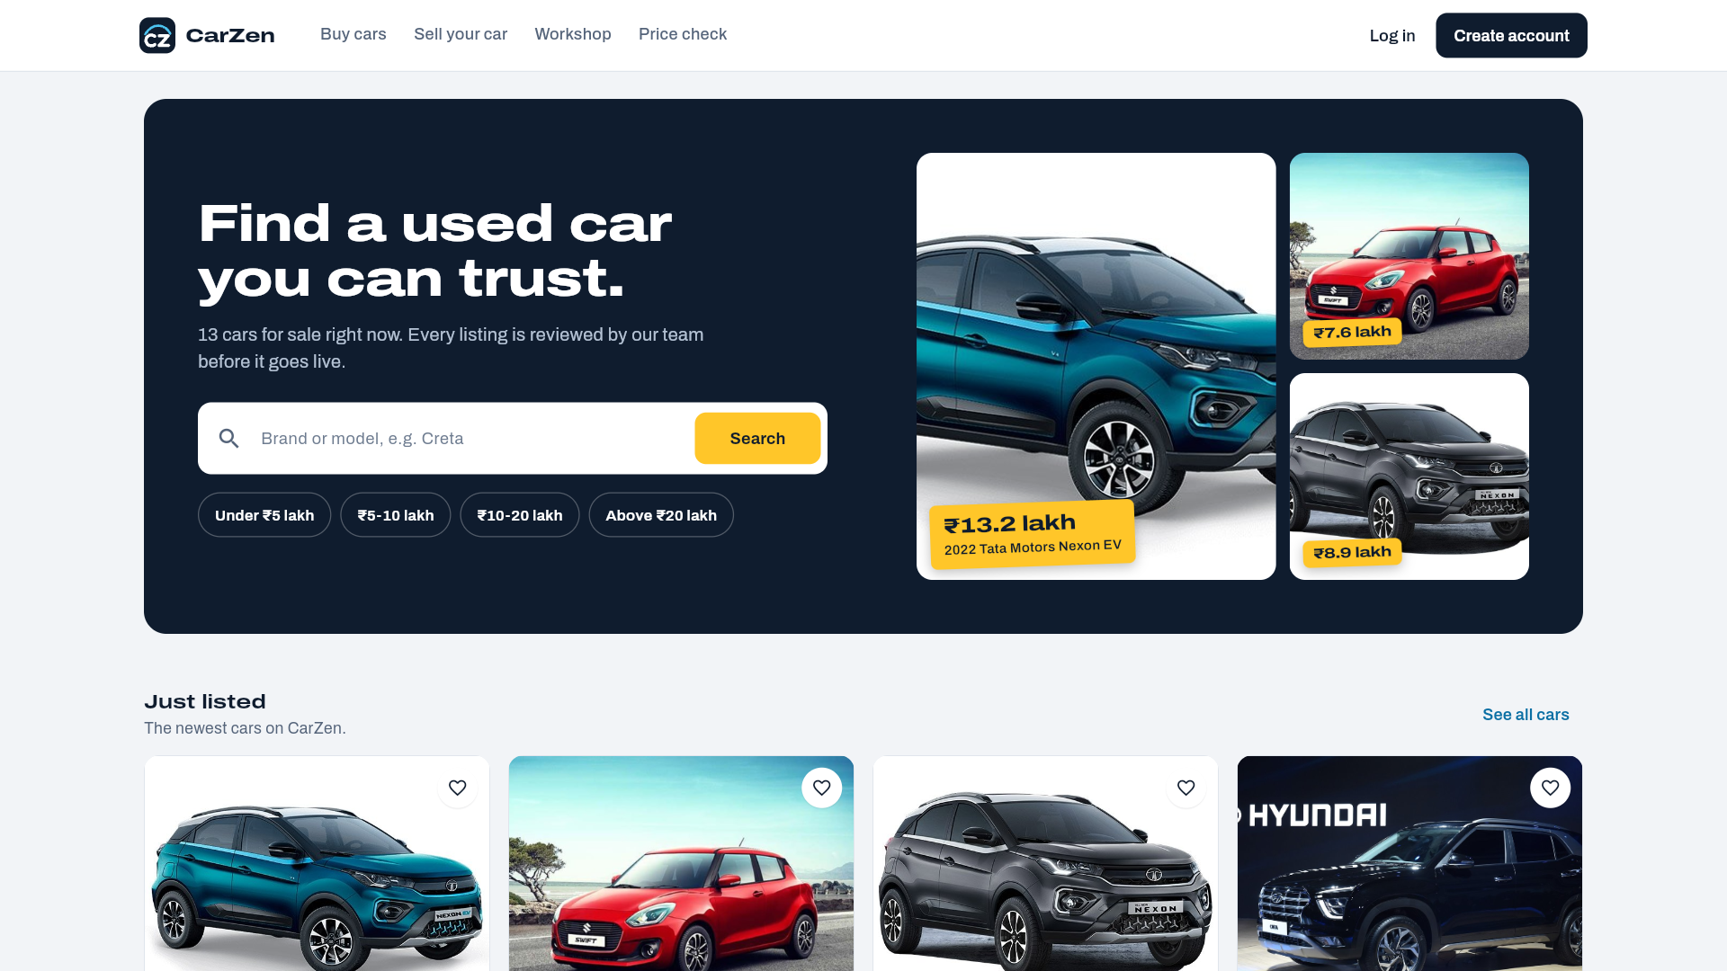
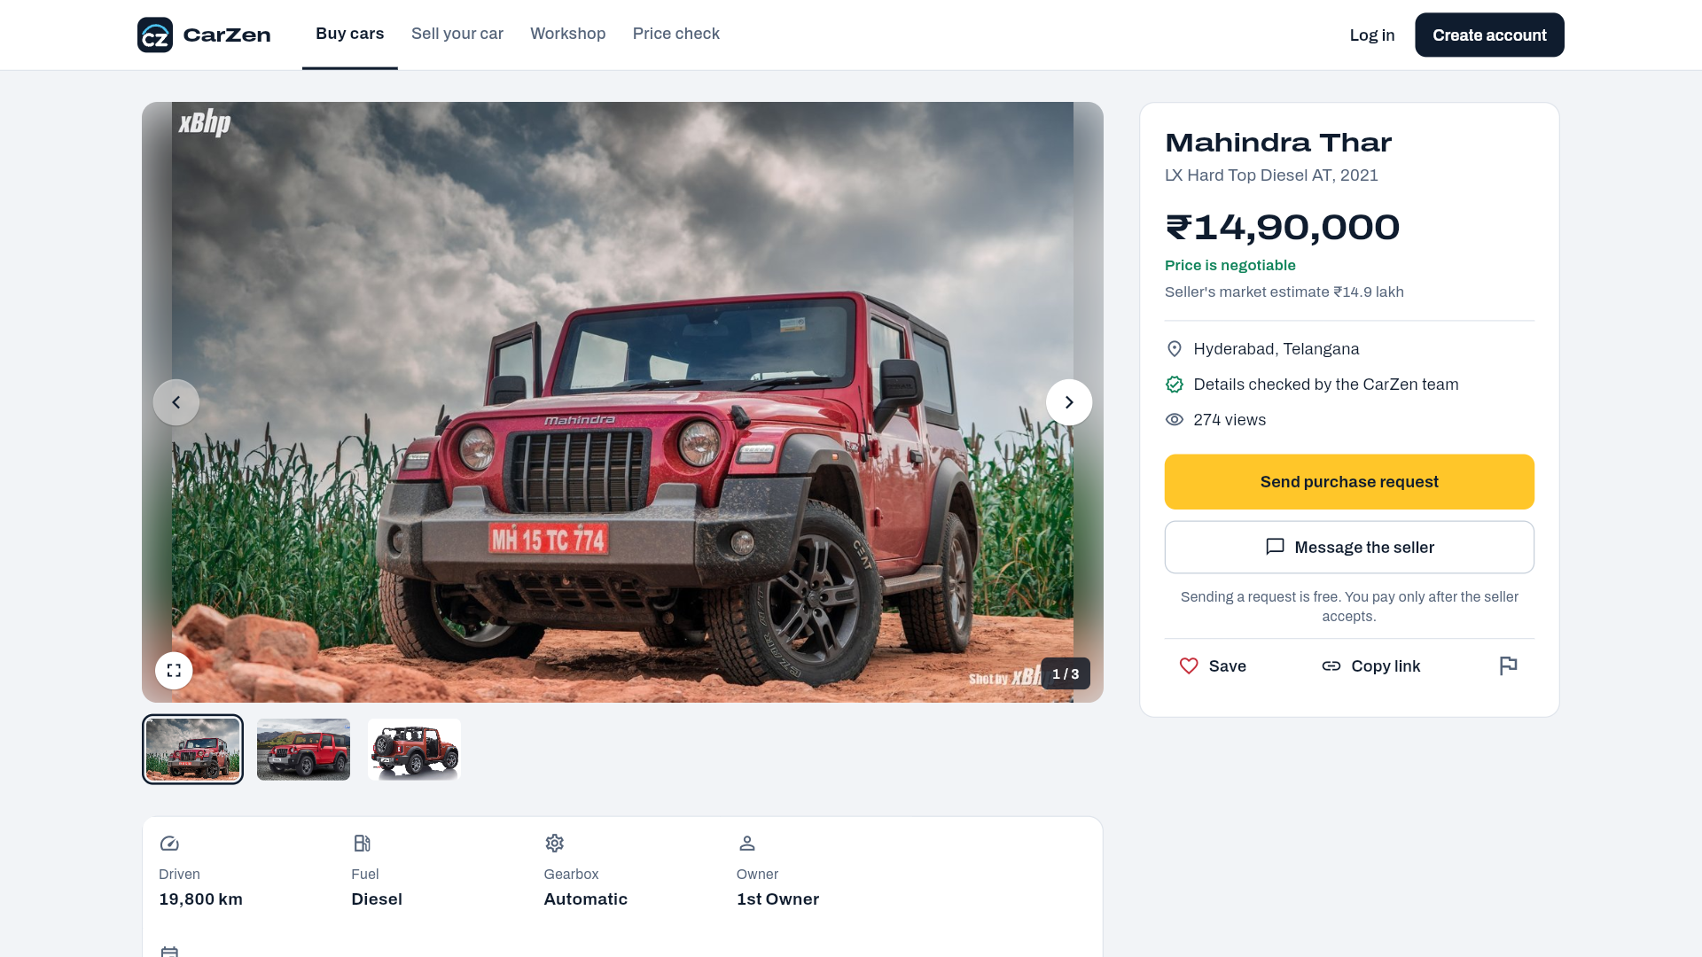
Login Page:
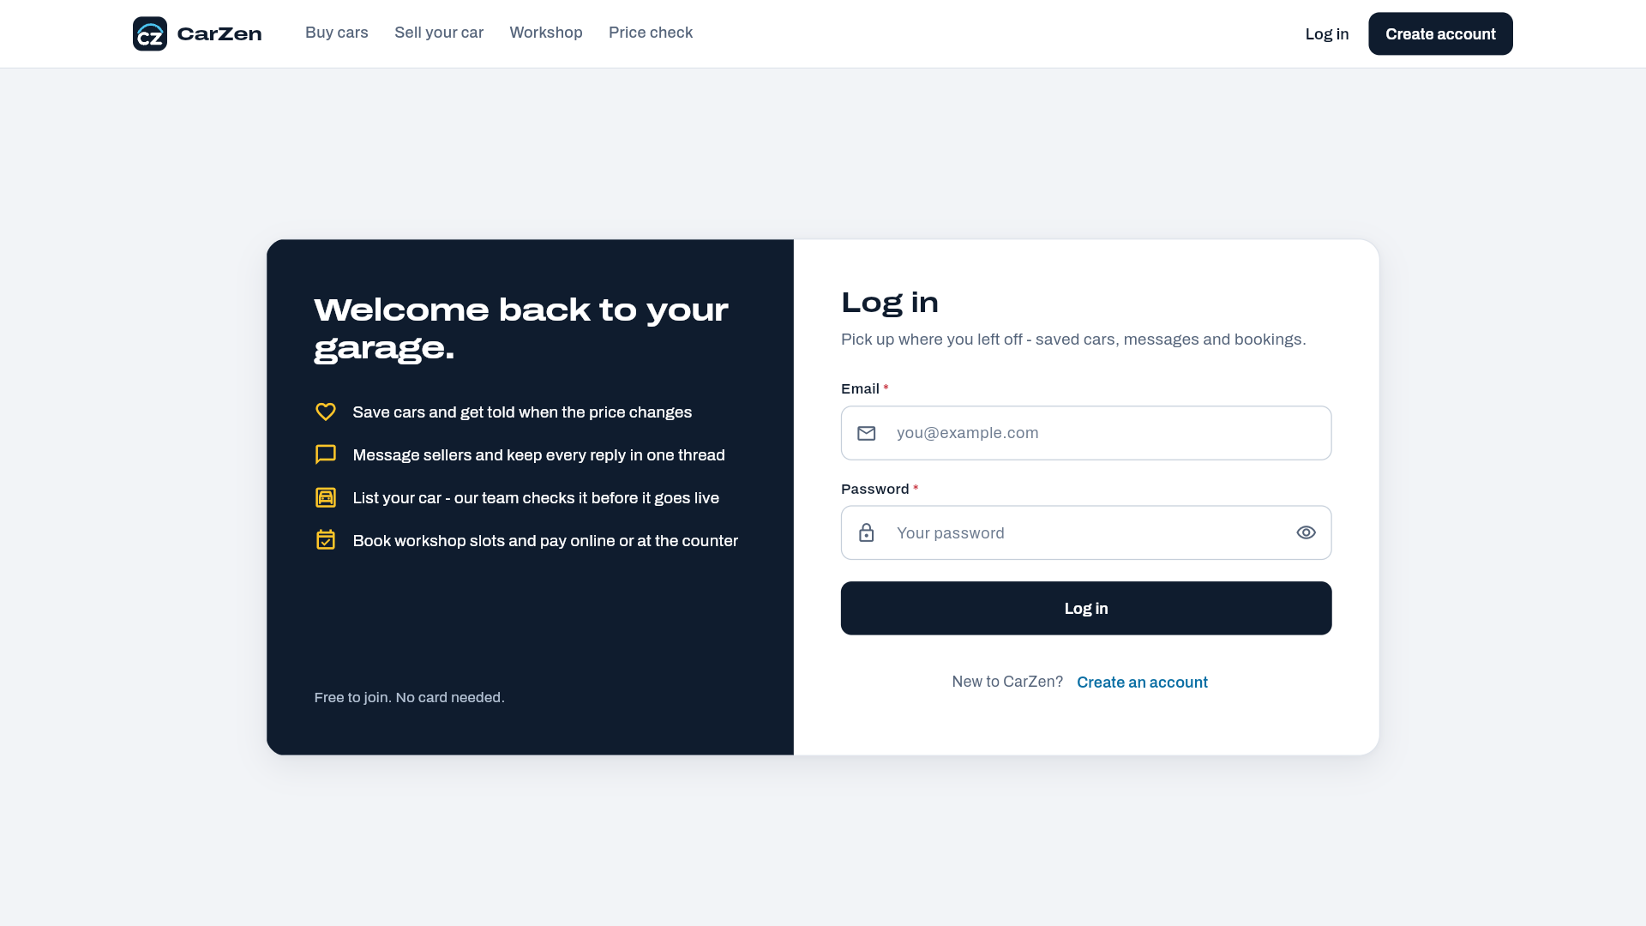
Register Page:
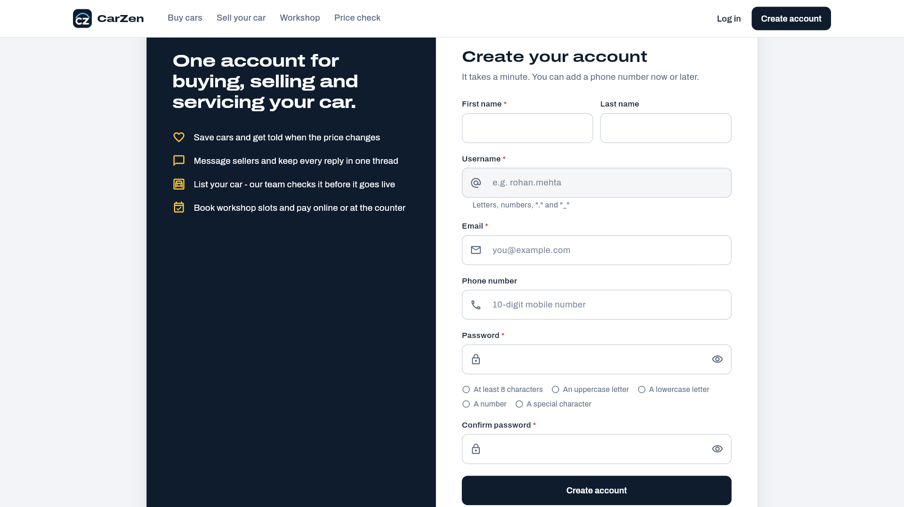
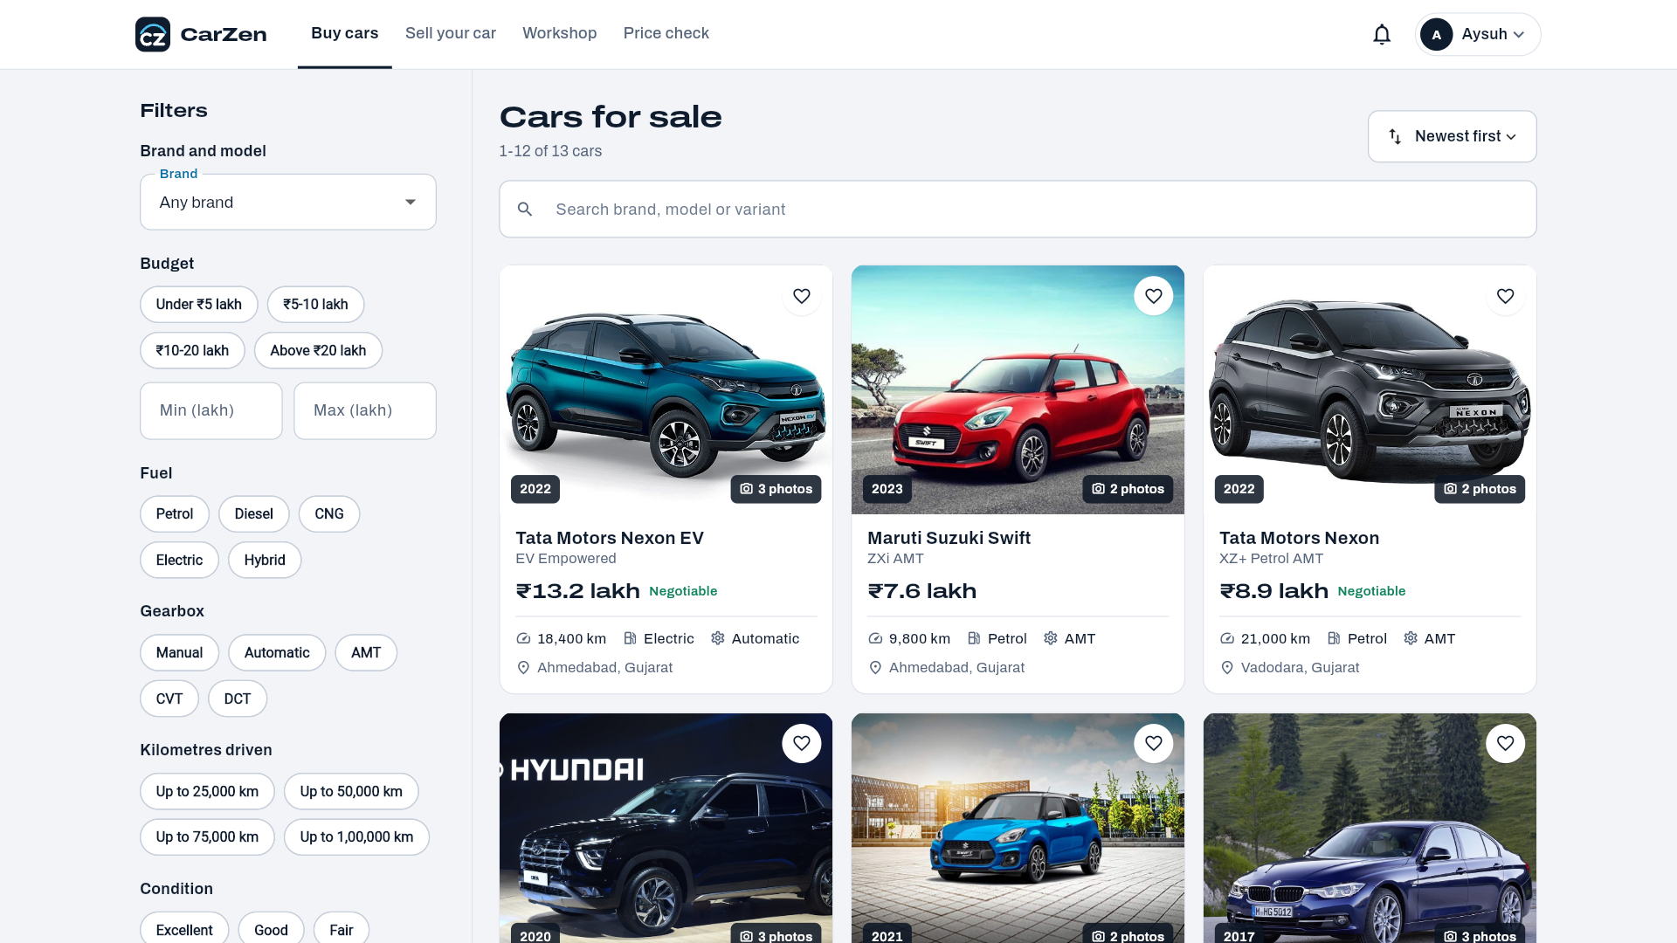
Price Prediction Page:
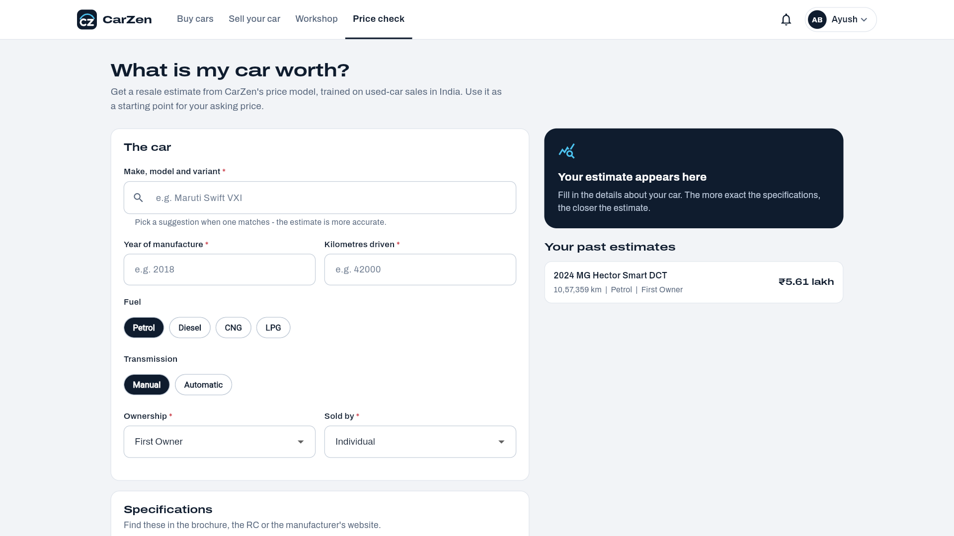

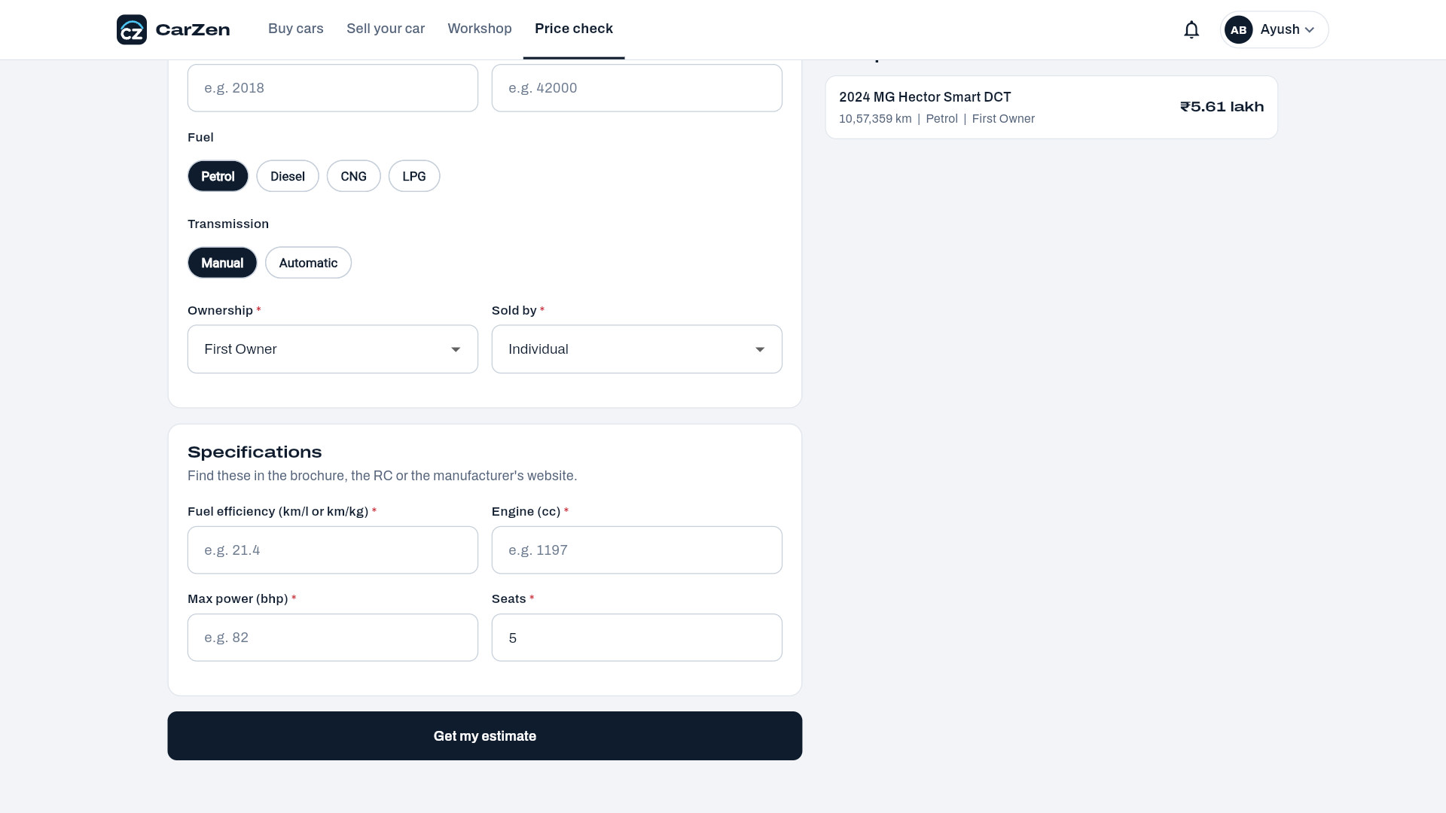
Admin:
Dashboard:
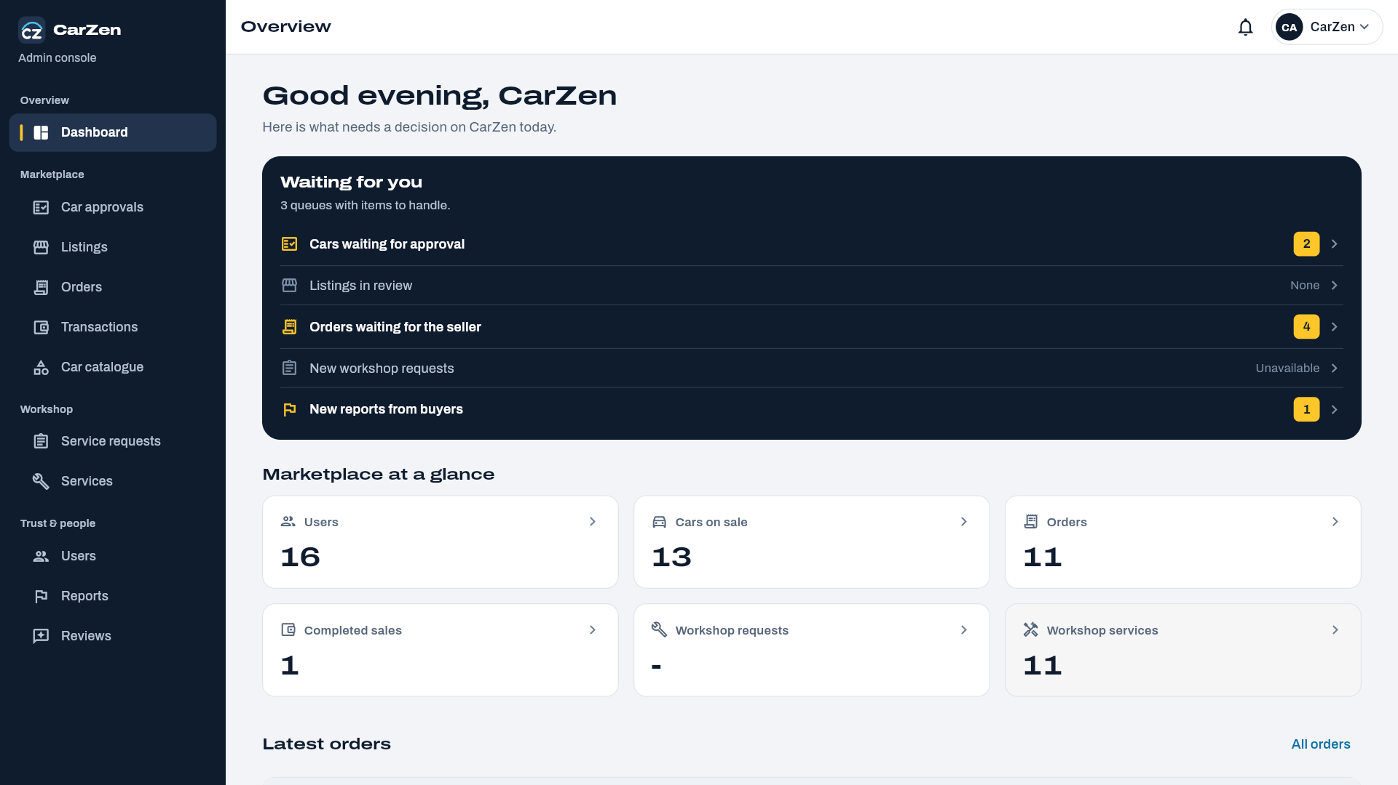

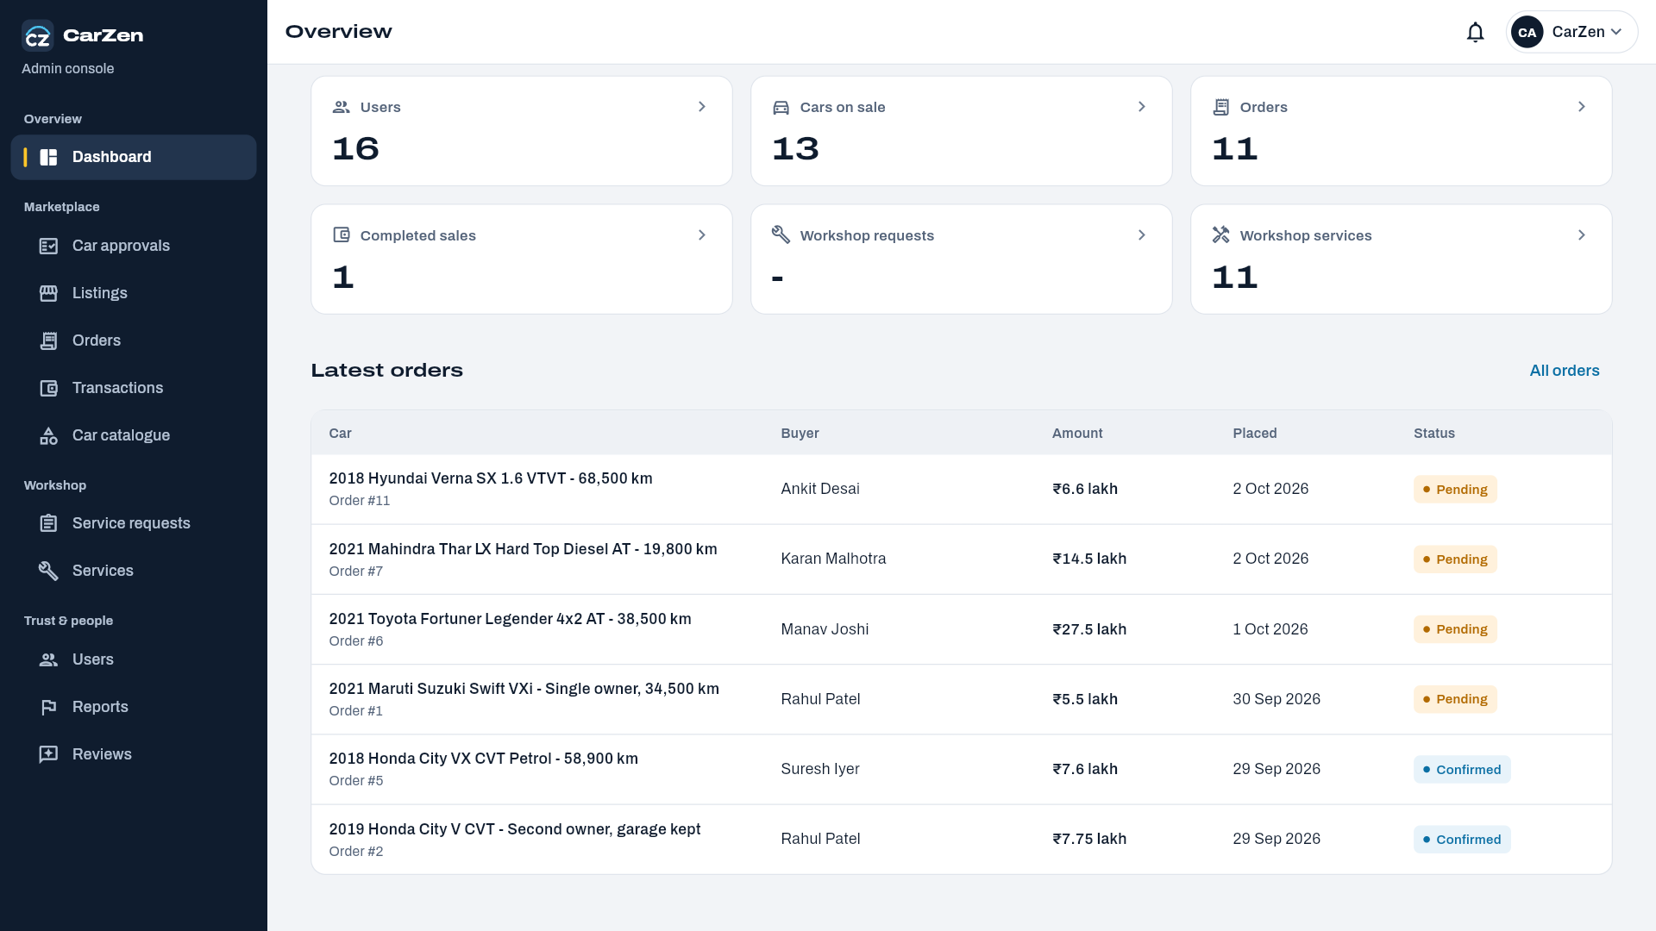

Car Approval page:
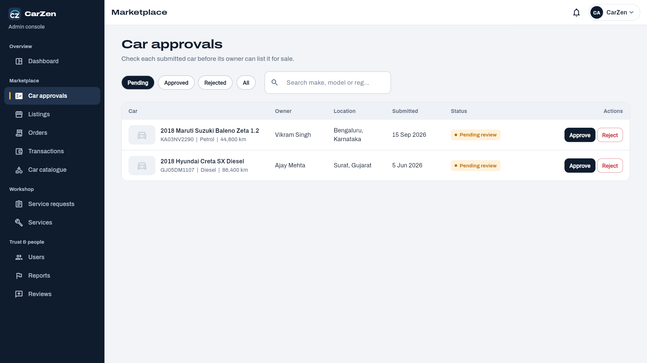
Car Listings page:
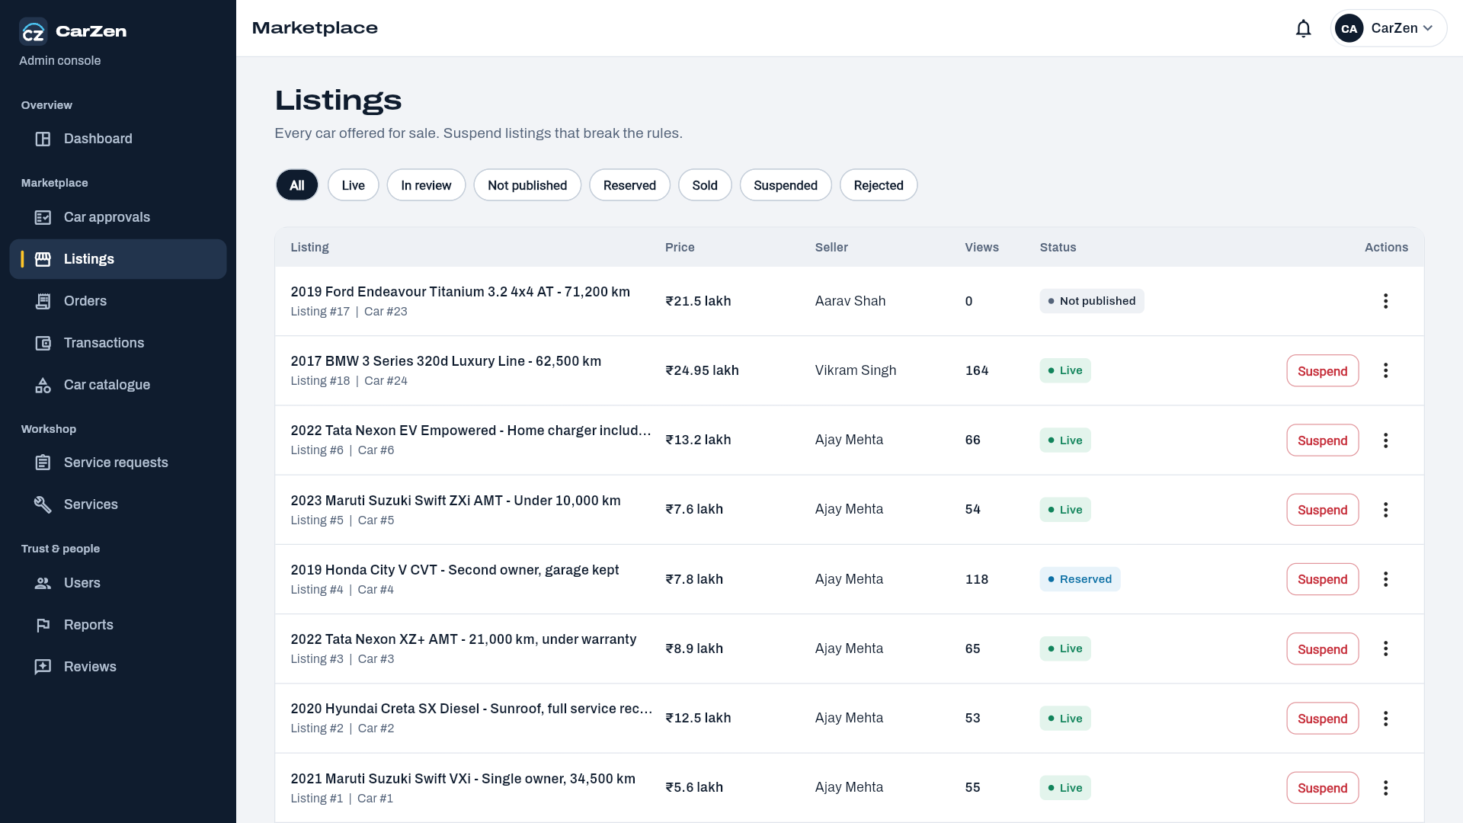
Order Page:
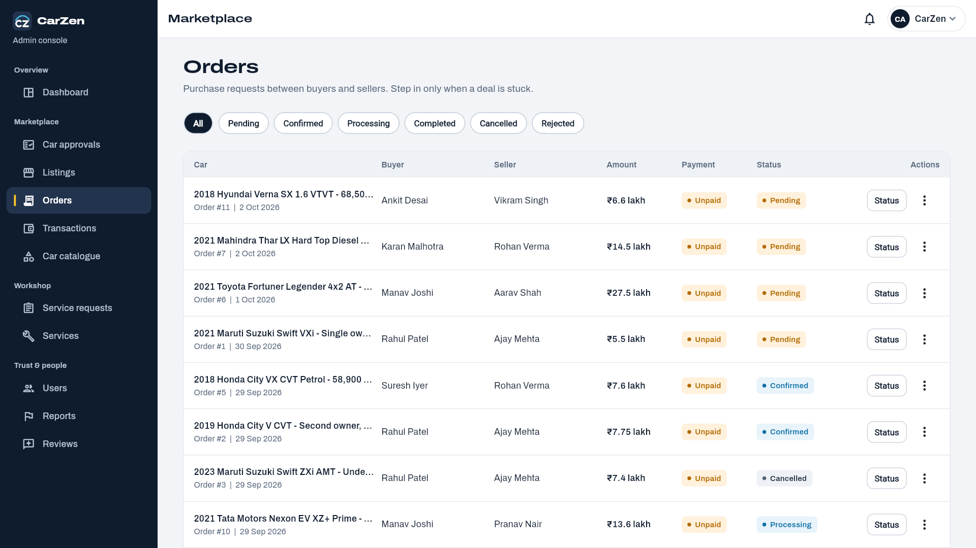
Transaction Page:
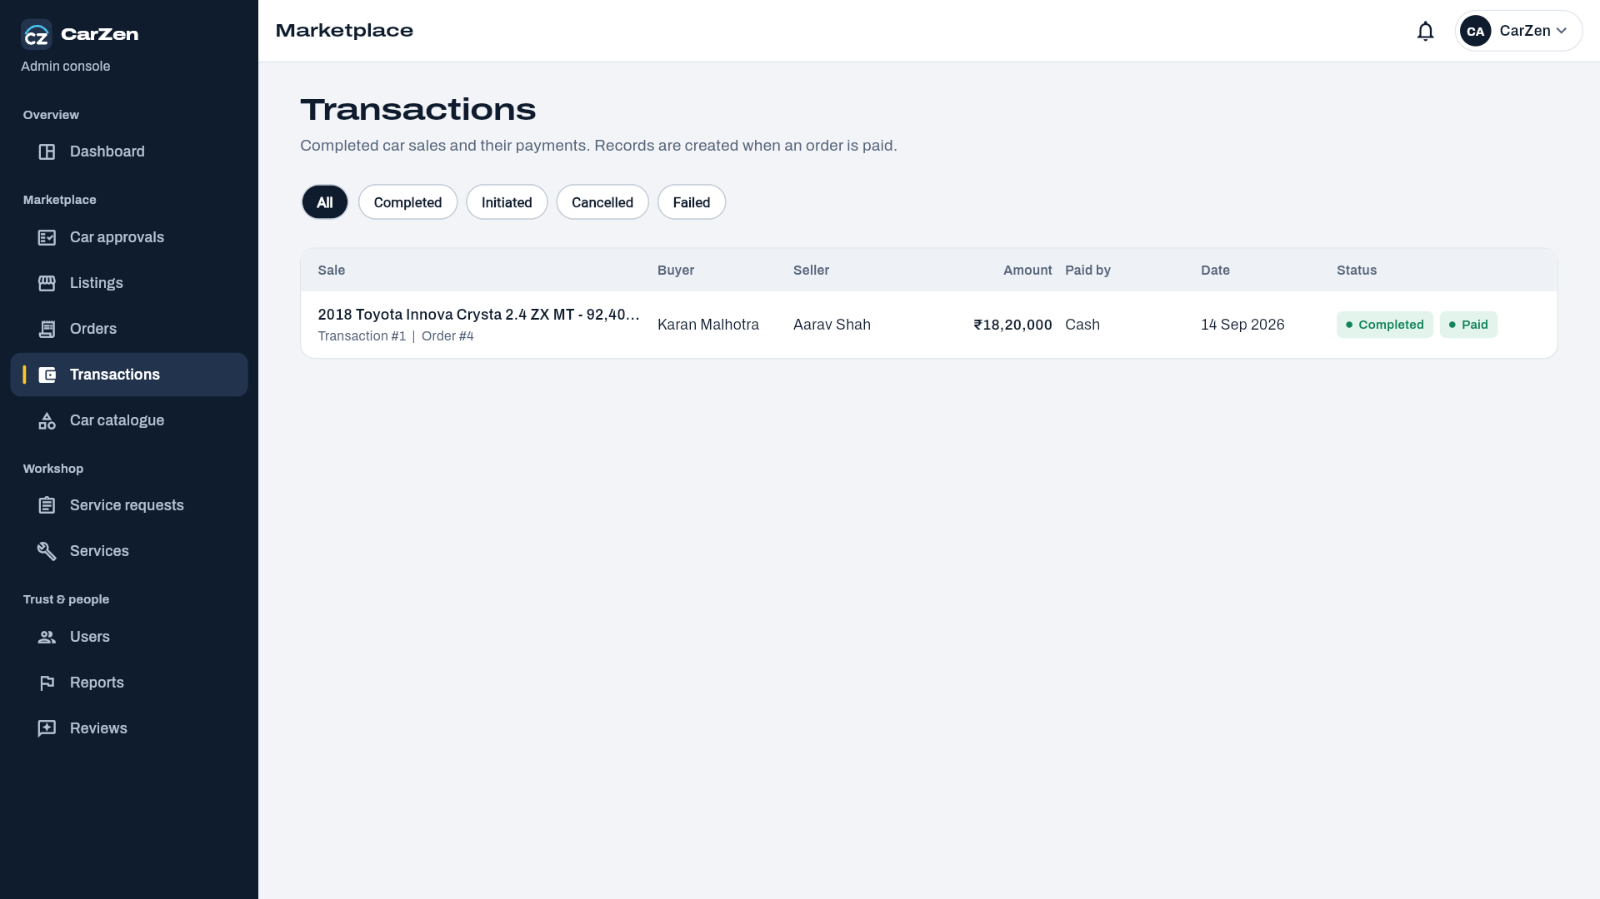
Car Catalogue Page:
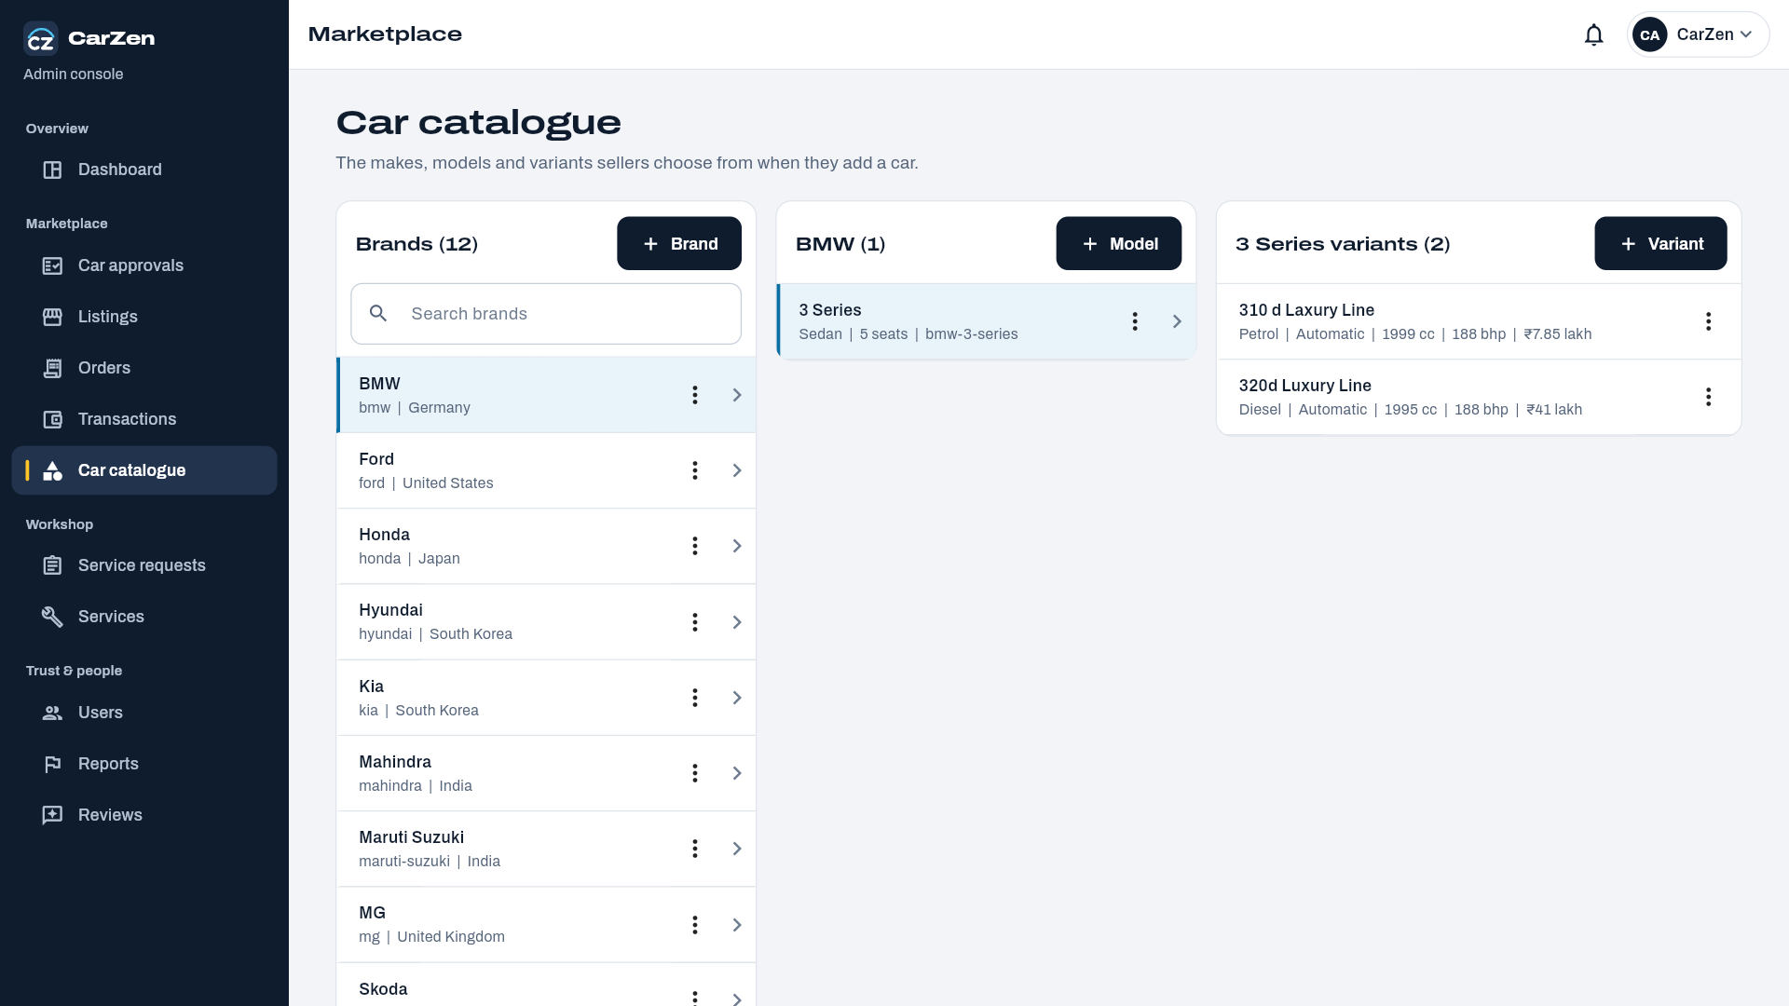
Service Catalog Page:
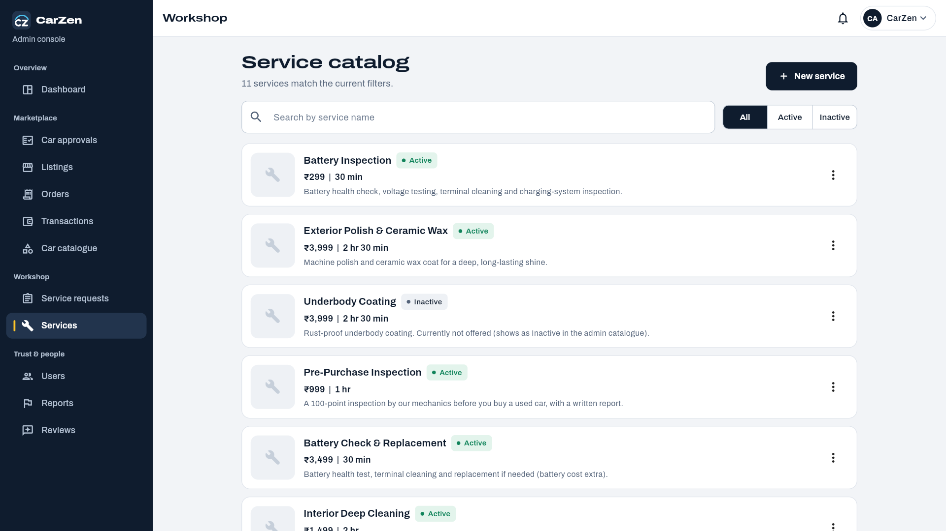
Users Page:
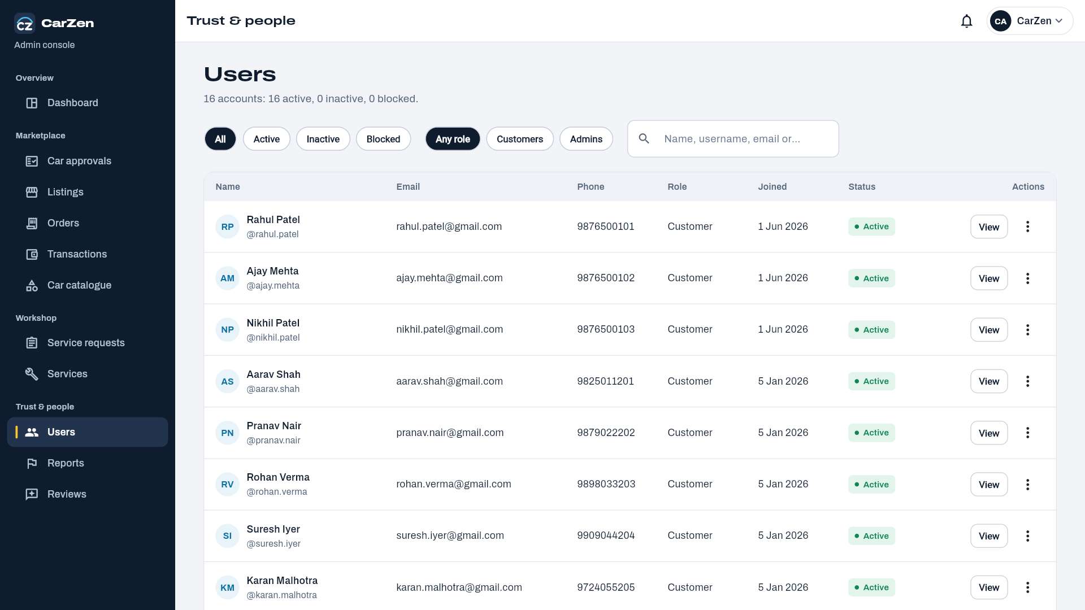
Report Page:
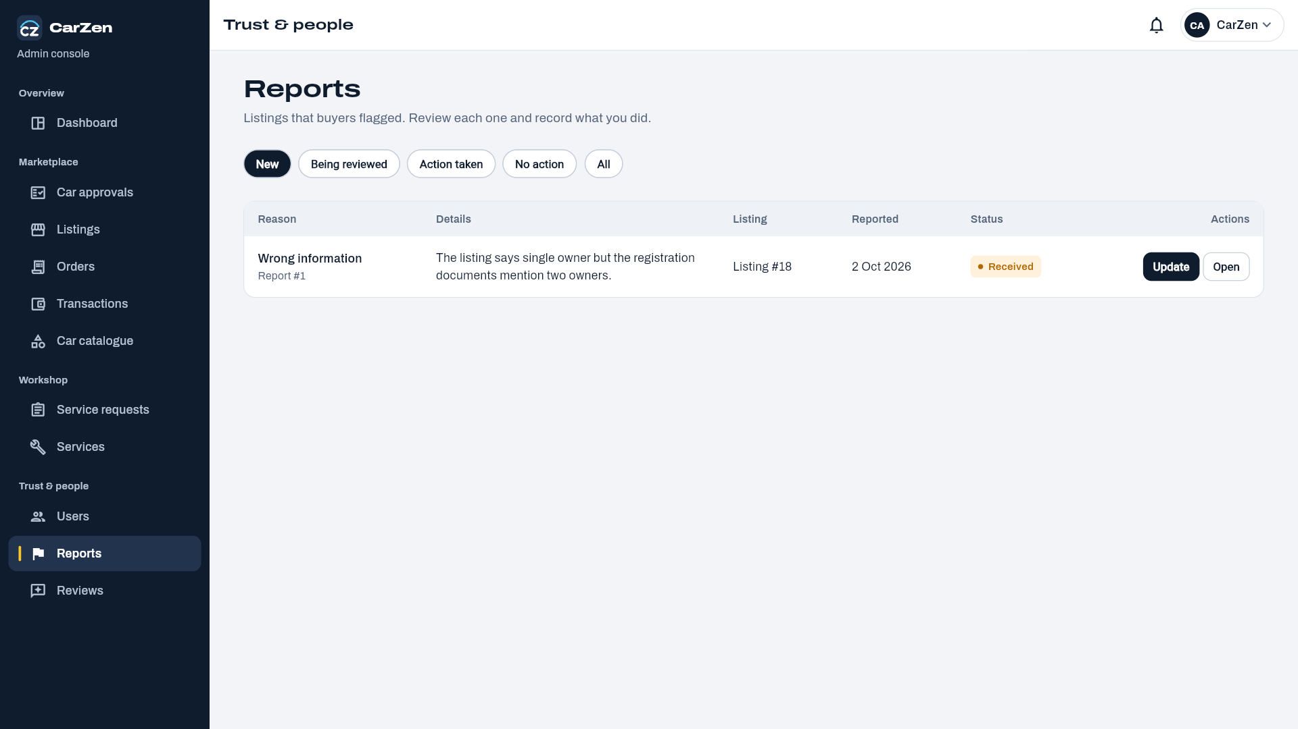
Review page:
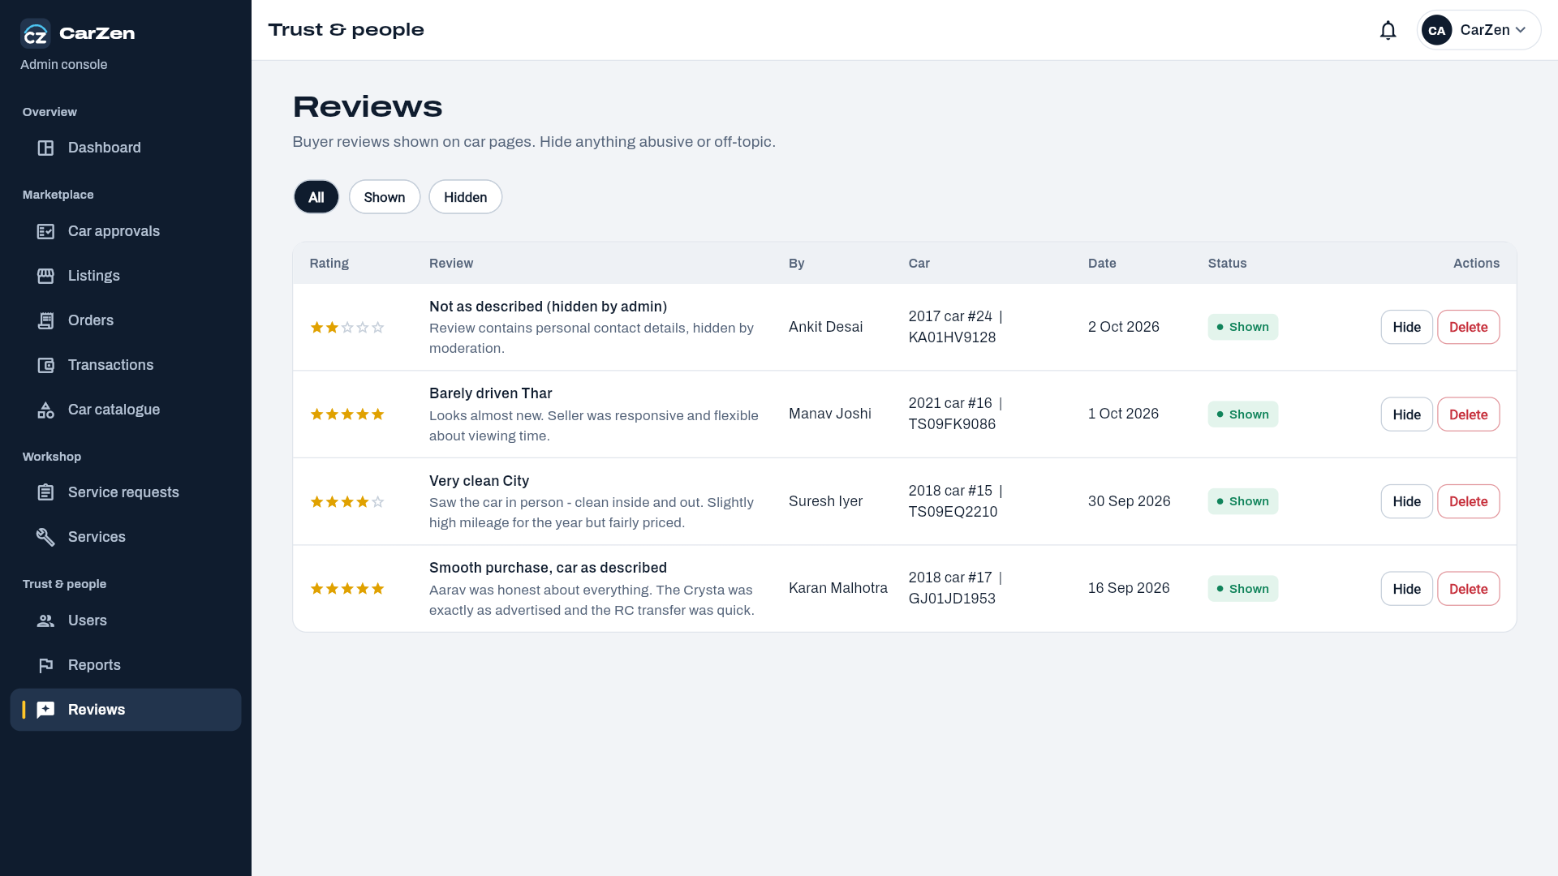
Admin Profile Page:
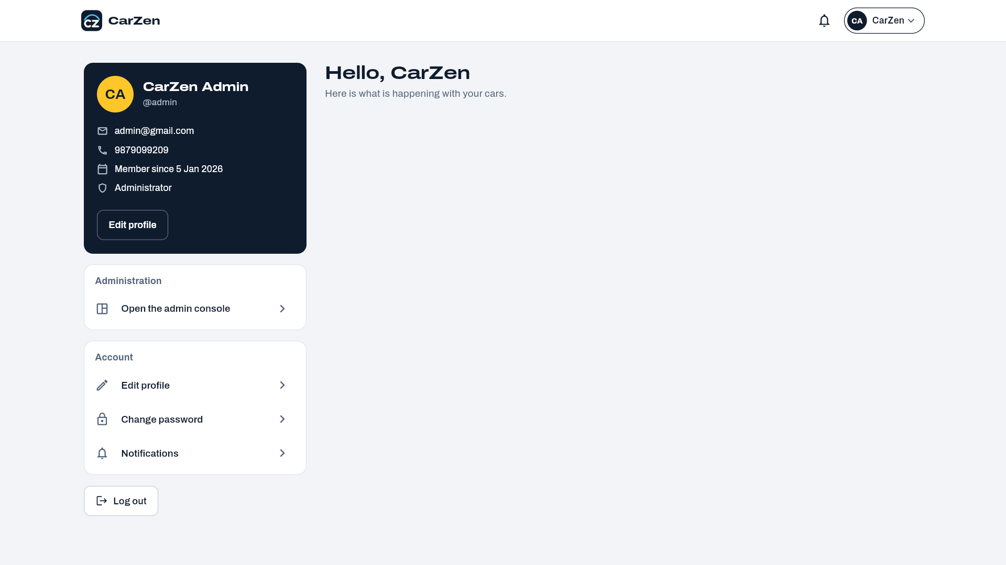
Workshop :
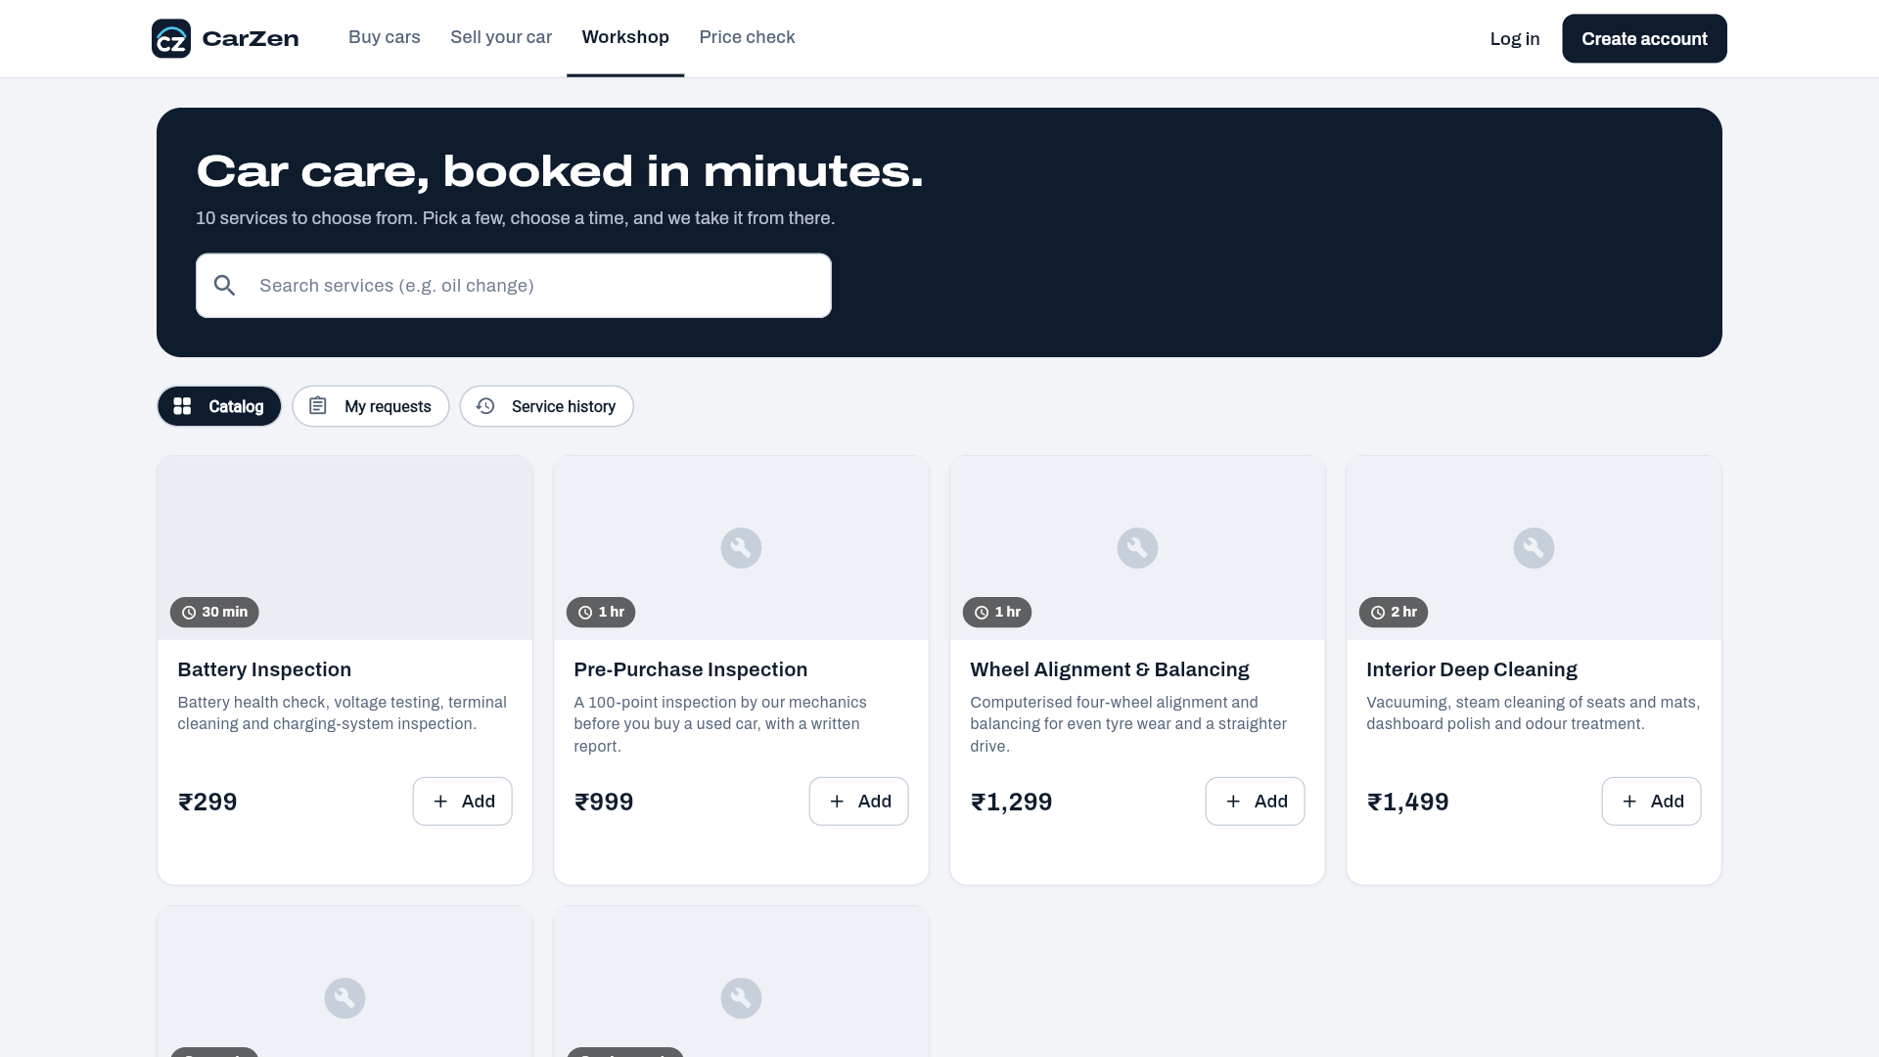

User Selling page:
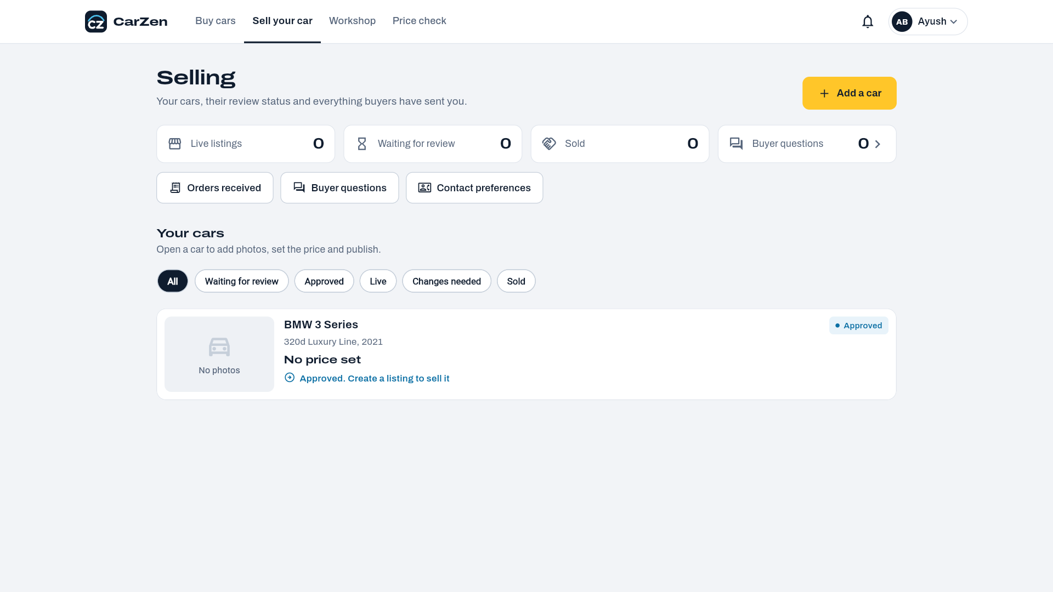

3.4 Report Design
Reports present the data stored in the CarZen MySQL database in a structured and readable form. They help buyers, sellers, service providers and the administrator review activity, take decisions and keep records. Reports are generated by FastAPI endpoints that query the database and are displayed in the Flutter application as lists, tables and summary cards. The reports designed for CarZen are listed below.
Report Name | Purpose | Main Users | Source Tables
User Report | Lists registered users with role, status and registration date. | Administrator | users
Car Inventory Report | Lists all cars with brand, model, variant, year, fuel type, mileage, city and verification status. | Administrator, Seller | cars, car_brands, car_models, car_variants
Active Listings Report | Shows current listings with asking price, negotiable flag, status, views and expiry date. | Administrator, Seller, Buyer | listings, cars, users
Seller Performance Report | Shows number of listings, views, inquiries and sold cars for each seller. | Seller, Administrator | listings, inquiries, transactions
Ownership History Report | Shows the ownership chain of a car with purchase/sale dates and prices. | Buyer, Seller, Car Owner | ownership_history, cars, users
Service History Report | Shows service type, date, cost, service center and items for a car. | Car Owner, Service Provider, Buyer | service_records, service_items, service_centers
Price Prediction Report | Shows predicted, minimum and maximum price with confidence score and input features. | Buyer, Seller, Car Owner | price_predictions, prediction_features
Transaction and Payment Report | Shows sale transactions with amount, payment method and payment status. | Administrator, Buyer, Seller | transactions, payments
Inquiry and Favourites Report | Shows inquiries received and cars saved as favourites. | Seller, Buyer | inquiries, favorites
Reviews and Reports Summary | Shows reviews submitted and complaints/reports raised against users or listings. | Administrator | reviews, reports

Report Layout 1: Active Listings Report
Report header: CarZen logo, report title, generated date and applied filters (city, brand, price range, status). Footer: page number and total record count.
Sr. No. | Listing Title | Brand / Model | Year | Mileage (km) | Asking Price | Status | Views
1 | Well-maintained Swift VXi | Maruti / Swift | 2019 | 42,000 | Rs. 5,50,000 | Active | 128
2 | Hyundai Creta SX Diesel | Hyundai / Creta | 2018 | 61,500 | Rs. 9,25,000 | Active | 94
3 | Honda City ZX CVT | Honda / City | 2020 | 28,300 | Rs. 10,40,000 | Sold | 210

Note: the values shown are sample data to illustrate the layout.

Report Layout 2: Service History Report
Report header: car registration number, brand, model, variant and current owner name.
Service Date | Service Center | Service Type | Items / Work Done | Odometer (km) | Cost
12-Jan-2024 | AutoCare Service, Ahmedabad | Periodic Service | Oil change, filter replacement | 38,500 | Rs. 4,200
20-Jul-2024 | AutoCare Service, Ahmedabad | Repair | Brake pad replacement | 44,200 | Rs. 3,800

Footer: total number of services and total service cost.
Report Layout 3: Price Prediction Report
Field | Details
Car Details | Brand, model, variant, manufacturing year, fuel type, transmission, mileage, owner count, condition, city
Predicted Price | Estimated market price returned by the machine learning model
Price Range | Minimum price to maximum price
Confidence Score | Reliability of the prediction in percentage
Model Information | Model name, model version and prediction date

Report Design Standards
- Every report has a title, generation date and the filters applied.
- Tables use fixed column headings and consistent alignment: text left-aligned, numbers right-aligned.
- Prices are shown in Indian Rupees (Rs.) and dates in DD-MMM-YYYY format.
- Reports can be searched, filtered and sorted in the application; administrator reports can be exported.
- Access to each report is limited by user role through the authentication layer.

4. Development and Implementation

4.1 Development
CarZen is developed as a cross-platform application with a Flutter frontend, a Python FastAPI backend and a MySQL database. The Flutter application communicates with the backend through REST APIs that exchange JSON data. The backend applies the business rules, accesses the database and calls the machine learning model to predict car prices.
Technology Stack
Layer | Technology | Purpose
Frontend | Flutter (Dart) | Cross-platform user interface for buyers, sellers, service providers and administrator.
Backend | Python, FastAPI | REST APIs, validation, authentication and business logic.
Database | MySQL | Relational storage of users, cars, listings, ownership, service, transaction and prediction data.
Machine Learning | Python (pandas, scikit-learn) | Training and use of the used-car price prediction model.
Authentication | JWT, password hashing | Secure login and role-based access.
Testing | Postman | Testing and verification of API endpoints.
Version Control | Git / GitHub | Source code management and team collaboration.

System Architecture
The system follows a three-tier architecture. The presentation tier is the Flutter application. The application tier is the FastAPI server, which contains routers, services and the prediction component. The data tier is the MySQL database, which stores all structured data. Requests flow from Flutter to FastAPI, then to MySQL or the prediction model, and the response returns to the screen.
Module Implementation
Module | Implementation Summary
User Management | Registration, login, JWT-based authentication, profile update and role-based access for buyer, seller, service provider and admin. Passwords are stored only as hashes (password_hash).
Car Management | Add, update and view cars with brand, model and variant details and car images (car_media). Soft delete is supported using deleted_at.
Car Buying / Search | Search and filter by brand, model, price, fuel type, transmission, year, mileage and city; view car details; save favourites; send inquiries to sellers.
Car Selling Module | Sellers create, update and remove listings, set asking price and negotiability, and track listing status and views.
Reselling Module | Maintains ownership_history for each car, including purchase and sale details, so buyers can see the ownership chain.
Car Service Module | Stores service centers, service records and service items; shows service history for each car.
Price Prediction Module | Takes car details from the user, runs the trained model, returns predicted, minimum and maximum price with a confidence score and stores the result in price_predictions and prediction_features.
Admin Module | Manages users, cars, listings, service centers, reviews, reports, transactions and notifications.

Main API Endpoints
Method | Endpoint | Description
POST | /auth/register | Register a new user
POST | /auth/login | Login and receive an access token
GET / PUT | /users/me | View and update own profile
GET | /cars | Search and filter cars
POST / PUT / DELETE | /cars, /cars/{id} | Add, update and remove a car
POST / GET | /listings | Create and view listings
PUT / DELETE | /listings/{id} | Update or remove a listing
POST / GET | /favorites | Save and view favourite cars
POST / GET | /inquiries | Send and view inquiries
GET | /cars/{id}/ownership | View ownership history
POST / GET | /service-records | Add and view service records
POST | /predict-price | Predict the price of a car
GET | /admin/users, /admin/listings | Administrator management and reports

Machine Learning Implementation
- Dataset: Historical used-car data containing brand, model, manufacturing year, mileage, fuel type, transmission, engine capacity, number of owners, condition, location and selling price.
- Preprocessing: Removal of duplicate and missing records, handling outliers, encoding categorical fields and scaling numeric fields.
- Model Training: Regression models are trained and compared using MAE, RMSE and R2 score; the best model is saved for use by the API.
- Integration: The saved model is loaded by FastAPI. The /predict-price endpoint validates input, produces the prediction and stores the input and result in the database.
Implementation Environment
- Operating system: Windows 10/11.
- Tools: VS Code or Android Studio, MySQL Workbench, Postman, Git.
- Runtime: Flutter SDK, Python 3.x with FastAPI and Uvicorn.
- Client: Android device or emulator, and web browser.

4.2 Coding Standards
Coding standards were followed so that the source code is readable, consistent and maintainable by all team members.
Area | Standard Followed
Naming (Python) | snake_case for variables, functions and files; PascalCase for classes; UPPER_CASE for constants.
Naming (Dart) | lowerCamelCase for variables and functions; UpperCamelCase for classes and widgets; snake_case for file names.
Naming (Database) | Plural snake_case table names (e.g. car_variants) and snake_case column names; id as primary key and table_id for foreign keys.
Code Style | PEP 8 for Python and the official Dart style guide for Flutter; consistent 4-space (Python) and 2-space (Dart) indentation.
Project Structure | Backend divided into routers, schemas, models, services and ml folders; Flutter divided into screens, widgets, models, services and providers.
Comments and Documentation | Docstrings for functions and short comments for complex logic; FastAPI auto-generated documentation for APIs.
Validation | Request validation using Pydantic schemas; form validation in Flutter before sending data.
Error Handling | Proper HTTP status codes and clear error messages; try/except handling around database and model calls.
Security | Password hashing, token-based authentication, role checks, parameterised queries/ORM to avoid SQL injection, and no secrets in source code (environment variables used).
Reusability | Reusable widgets in Flutter and reusable service functions in the backend to avoid duplicate code.
Version Control | Meaningful commit messages, feature-wise branches and regular pushes to GitHub.

5. Testing
Testing was carried out to verify that CarZen works according to the requirements. Unit testing was done for individual functions and APIs, integration testing for communication between Flutter, FastAPI and MySQL, and functional testing for complete user scenarios. API endpoints were tested using Postman, and the user interface was tested manually on the Flutter application.

5.1 Test Cases
ID | Test Case | Input / Action | Expected Result | Status
TC01 | Register with valid details | Name, unique email, username, password | User account is created | Pass
TC02 | Register with existing email | Email already in database | Error: email already exists | Pass
TC03 | Register with empty required field | Blank email or password | Validation message is shown | Pass
TC04 | Login with valid credentials | Correct email and password | Login successful, token returned | Pass
TC05 | Login with wrong password | Valid email, wrong password | Error: invalid credentials | Pass
TC06 | Access protected page without login | No token | Access denied (401) | Pass
TC07 | Update user profile | Changed name and phone number | Profile is updated | Pass
TC08 | Admin-only access by normal user | Buyer calls admin endpoint | Access forbidden (403) | Pass
TC09 | Search cars by brand | Brand = Hyundai | Only Hyundai cars are listed | Pass
TC10 | Filter by price range and fuel type | Rs. 3-8 lakh, Petrol | Matching cars are displayed | Pass
TC11 | Search with no matching result | Unavailable brand/model | "No cars found" message | Pass
TC12 | View car details | Select a car | Complete details and images are shown | Pass
TC13 | Add car to favourites | Tap favourite icon | Car is saved in favourites list | Pass
TC14 | Send inquiry to seller | Message for a listing | Inquiry is stored and visible to seller | Pending
TC15 | Create a listing | Valid car and price details | Listing is created with Active status | Pending
TC16 | Create listing with invalid price | Negative or empty price | Validation error | Pending
TC17 | Update a listing | Change asking price | Listing is updated | Pending
TC18 | Remove a listing | Delete own listing | Listing is removed from search results | Pending
TC19 | Seller edits another seller's listing | Different seller id | Action is rejected | Pending
TC20 | View ownership history | Select a car | Ownership chain is displayed in order | Pending
TC21 | Add service record | Date, type, cost, center | Record is saved | Pending
TC22 | View service history | Select a car | Records shown latest first | Pending
TC23 | Predict price with valid input | Brand, model, year, mileage, fuel, owners | Predicted price, range and confidence returned | Pending
TC24 | Predict price with missing fields | Mileage omitted | Validation error, no prediction | Pending
TC25 | Prediction result is stored | Run prediction | Record added to price_predictions | Pending
TC26 | Admin manages users | Block a user | User status changes and login is denied | Pending
TC27 | Admin removes reported listing | Select reported listing | Listing is removed | Pending
TC28 | Notification delivery | New inquiry received | Seller sees a notification | Pending

Status "Pass" indicates test cases of modules completed so far (user, authentication and car buying). Status "Pending" indicates test cases of modules planned in the timeline (selling, service and prediction) and should be updated with the actual result after execution.

6. Proposed Enhancements
The following features can be added to CarZen in future versions to make the system more useful and complete.
- Online Payment Integration: Secure payment gateway for booking amounts, service payments and listing fees.
- Improved Prediction Model: Retrain regularly with fresh market data and add features such as accident history, tyre condition and demand trends to improve accuracy.
- Car Comparison with Charts: Side-by-side comparison of specifications, price and ownership cost.
- Service Booking and Reminders: Online booking with service centers and reminders for service, insurance and RC expiry.
- Vehicle History Verification: Integration with RTO or insurance data to verify registration, VIN and ownership.
- Push Notifications: Alerts for price drops, new matching listings and inquiry replies.
- Recommendation System: Suggest cars based on user search, favourites and budget.
- Advanced Admin Analytics: Dashboards with sales trends, popular brands and user growth.
- iOS and Web Release: Publish the Flutter application on iOS and the web in addition to Android.

7. Conclusion
CarZen: Car Selling, Buying, Service System provides a single platform where users can buy, sell and resell cars, manage vehicle service records and estimate the price of a car using machine learning. It addresses common problems of the existing process, namely scattered information, manual price estimation and the lack of vehicle history.
The system was analysed, designed and developed using Flutter, Python with FastAPI and MySQL. Requirement analysis, use case diagrams, a data dictionary covering the complete database, user interface design and report design have been prepared. The user, authentication and car buying modules are implemented and tested, and the selling, service and price prediction modules are planned for the remaining phases of the timeline.
The project helped the team gain practical experience in cross-platform application development, REST API design, relational database design and applying machine learning in a real application. With the proposed enhancements, CarZen can grow into a complete and reliable automobile marketplace that improves transparency between buyers and sellers.

8. Bibliography
The following books and websites were referred to during the development of this project.
- Flutter Documentation - https://docs.flutter.dev
- Dart Programming Language - https://dart.dev/guides
- FastAPI Documentation - https://fastapi.tiangolo.com
- Python Documentation - https://docs.python.org/3
- MySQL Reference Manual - https://dev.mysql.com/doc
- Pydantic Documentation - https://docs.pydantic.dev
- scikit-learn Documentation - https://scikit-learn.org/stable
- pandas Documentation - https://pandas.pydata.org/docs
- Postman Learning Center - https://learning.postman.com
- Git and GitHub Documentation - https://docs.github.com
- Roger S. Pressman, Software Engineering: A Practitioner's Approach, McGraw-Hill.
- Ian Sommerville, Software Engineering, Pearson.
- Elmasri and Navathe, Fundamentals of Database Systems, Pearson.

